*The drivers of landscape pattern:*

*Physical template, biotic interactions and disturbance regime*

**PRE-CLASS READING**

**Overview**

*What Is the Ecological Issue?*

Landscape Ecology seeks to understand the interactions between ecological patterns and processes across varying spatial scales (Turner 2005). In some landscapes, extreme gradients drive patterns through their effect on physical processes. For example, the large elevation gradients in mountainous landscapes influence temperature and moisture, and thus for plants with different tolerances at different elevations. However, subtle gradients also occur frequently in nature and can similarly influence variation in the physical and ecological variables that influence landscape pattern. To appreciate variability in the spatial scales of patterns and processes, this introductory lesson in Landscape Ecology compares two landscapes with large and small gradients. This exercise should broaden your understanding of which processes form patterns in landscapes, how they do so, and how pattern influences processes. You will draw on ecological concepts you should have already learned, synthesizing them and applying them in new ways to give you a spatially explicit context to understand Ecology.

*Scale, grain, and extent of landscape pattern*

When we study landscape pattern, our data are characterized by the grain and extent of the data. The **grain**is the resolution of the data; for example, this might be a 0.25 m2 quadrat in a detailed plant survey, or 100 km2 in a study using satellite images. The spatial **extent**refers to the total space occupied by the whole dataset. In the detailed plant survey mentioned above, the extent of the data might be a few hectares of abandoned farm field; for the study with coarser grain, the extent might be a country or continent. Grain and extent are closely linked: datasets with large extent usually have coarse grain, while those with smaller extent usually have fine grain simply because of the time, money, or data processing constraints of conducting research. It is important to match the grain and extent (together referred to as the **scale**) to the pattern that you wish to study. Too coarse a grain will miss the important elements of the pattern, while too small an extent may not capture enough of the pattern of interest to be able to analyze it.

Across a single landscape, patterns can occur at many scales and be nested within each other. It is important to understand how patterns are nested within each other to appreciate the limits of any one observation. For example, there may be pattern in landscaping around a single home (the extent is the property unit) consisting of patches of different flowers, bushes, and grass (the grain at this scale might be approximately 1 m2). Zooming out to the larger extent of the neighborhood, you may observe a pattern made up of several property units. At this scale, the property unit becomes the grain size. Furthermore, zooming out even further to the extent of a sprawling city may show a pattern of different neighborhoods. At this largest scale, individual neighborhoods might become the grain appropriate for the observed patterns. Within the neighborhoods, there are nested patterns of individual yards; which scale is the best for an analysis depends on the question being asked. In addition, the spatial scale of a pattern is closely linked to the temporal scales of associated processes. Back to our example of neighborhood yards: a gardener can influence the pattern within his or her yard in a single afternoon. In contrast, changes in development patterns at the scale of a whole city would take years or decades.

In this case study, we will consider vegetation patterns and ecological processes at a landscape scale. At this scale, there are many biotic and abiotic patterns to discuss, but we will focus primarily on three main drivers of vegetation patterns and some of their consequences. First, physical differences (e.g. temperature and moisture differences driven by geology and geomorphology) among different parts of the landscape make conditions more or less optimal for certain plant species to grow. In addition to the **physical template** of the landscape, **biotic interactions** among plants further influence the vegetation pattern. Finally, the **disturbance regime** contributes to the pattern of vegetation on the landscape. Importantly, the interaction between ecological process and landscape pattern is not unidirectional; vegetation patterns themselves shape the ecological processes on the landscape, as will be discussed below. First, let us introduce you to our focal landscapes.

*Study Areas*

The Sierra Nevada mountain range runs 640 km along a north-south axis in California and Nevada and has topography that spans thousands of meters. This large elevation gradient drives climatic conditions by creating predictable variation in temperature and moisture from low to high elevation. These changes in environmental conditions (driven by elevation gradients) lead to patterns of vegetation composition. Large trees are the dominant vegetation of the Sierra Nevada, and different plant **communities** are usually defined by their dominant tree species. Based on their physiological ability to produce biomass and reproduce at the temperature and moisture conditions at a given elevation, different plant communities exist in bands on the mountainsides.

However, the environmental conditions in which a plant *could* exist (**theoretical niche**) likely differ from those conditions in which they actually exist (**realized niche**). **Competitive interactions** between species play a role in the vegetation pattern of this landscape. Highly competitive species under the given environmental conditions will exclude other, less competitive species, displacing them to other areas of the landscape (or from the landscape altogether). Species such as incense cedar (*[Calocedrus decurrens](http://en.wikipedia.org/wiki/Calocedrus_decurrens" \o "Calocedrus decurrens)*) and Ponderosa pine (*Pinus ponderosa)* are more drought resistant than other Sierra Nevada species (Urban et al. 2000), and therefore occupy places in the landscape too dry for other species. In contrast, the colder areas in the mountains are occupied by vegetation communities that include Western white pine (*Pinus monticola*) and Lodgepole pine (*Pinus contorta*), which can tolerate lower average temperatures (Urban et al. 2000).

In contrast to the large elevation gradients of the Sierra Nevada, elevation in the Florida scrub varies on the order of only tens of meters (Boughton et al. 2006). The Florida scrub is located along the Lake Wales Ridge, a 2 million year old relic dune which runs approximately 240 km north to south down the center of the Florida peninsula (Weekley et al. 2007) The sandy soils of this landscape are **xeric**, and retain little water despite receiving 136 cm of precipitation annually(Menges and Hawkes 1998, Lohrer 2007). The landscape pattern within Florida scrub can be described at many scales: at a larger extent, seasonal wetlands (on the order of 2000 m2 in area) exist in low-lying depressions, embedded within a matrix of scrubby vegetation (Ficken and Menges 2013). At a smaller extent, within the scrubby vegetation matrix, patches of different vegetation communities contrast with bare sand gaps that are largely devoid of vegetation. Rosemary scrub exists on knolls with particularly high covers of bare sand and Florida rosemary (*Ceratiola ericoides*), an **allelopathic** shrub.

**Background Information:**

*Landscape pattern and the physical template*

Habitats of different plant species are determined in part by physical differences in the landscape. These physical differences include temperature, soil moisture, light availability, and exposure to wind, and are collectively referred to as the **physical template.** Because plants differ in their physiological ability to persist under different physical conditions (e.g. drought or wind exposure) and have different resource requirements (e.g. sunlight or soil moisture), the physical template is one of the three main drivers of vegetation patterns on a landscape.

In the following activity, you will contrast the role of the physical template on landscape pattern in two different landscapes. First, consider the physical template on a mountainside. If you have hiked in the mountains, you may have noticed that the climate changes as you go up in elevation (it becomes colder and wetter as you ascend). Temperature decreases as you rise in elevation because the air pressure is lower at higher altitude. This phenomenon is called **adiabatic cooling** and can be approximated by a 10°C temperature decline for every 1000 m rise in elevation (adiabatic **lapse rate)** for dry air. As increasing elevation drives decreases in temperature, water condenses and the climate becomes wetter. Differences in elevation therefore primarily influence water availability and temperature, and vegetation sorts according to its ability to persist under these conditions. This means that species with a greater ability to persist in cold conditions can exist at higher elevations, and drought-resistant species can exist on the drier, lower slopes of the mountain. How does this result in patterns in mountainous landscapes? Plant species with similar physical requirements form bands of at different elevations on a mountain side.

In contrast to mountainsides, the Florida scrub is a landscape with very little topography. Here, small changes in the physical template (1-2 meters, termed microelevation) influence the patterning of scrub landscapes (Boughton et al. 2006). At this scale, the physical template still drives vegetation patterns by influencing water availability, but it does so through the distance to the water table. Thus microelevation, too, results in plants sorting according to their ability to withstand drought and inundation. However, the relationship between water availability and [micro]elevation is positive (wetter in higher elevations) in mountainous landscapes but negative (drier at higher microelevations) in the Florida scrub.

*Landscape pattern and biotic interactions*

**Biotic interactions** manifest in pattern across landscapes via many forms of biotic processes. Species **demography**, **competitive interactions**, predation, and dispersal are just some of the ways biotic interactions among species and drive pattern in a landscape. Our two focal landscapes share several types of biotic interactions, but this exercise will focus on two: **competitive interactions** and **allelopathy**. Plants require many different resources (water, light, nutrients, etc.) to survive, and specific requirements differ by species. Species can usually tolerate some range of resource availability, but may have peak growth rates at an optimum level of resource availability. When two species have resource needs that overlap, competition for that resource ensues: if one species is a better competitor for the limiting resource, species that are less efficient at acquiring it are displaced out of the range of optimal resource availability, but within the range of acceptable resource availability. **Competitive interactions** are thus a primary driver of vegetation zonation on mountain slopes.

The Florida scrub landscape also demonstrates vegetative sorting from resource competition, but includes the additional biotic interaction of **allelopathy**. Allelopathic plants generate compounds that actively interfere with the growth or survival of other species around them. Allelopathic compounds may even prevent other species from germinating (Richardson and Williamson 1988)! These compounds help allelopathic species maintain a buffer space around them, and thus reduce competition for the resources they require for optimal growth. In the Florida scrub, Florida rosemary(*Ceratiola ericoides*) generates allelopathic compounds from its leaf litter as well as through root exudates. The result of this biotic process is a patchy landscape consisting of bare sand and Florida rosemary bushes.

*Landscape pattern and disturbance regime*

The final group of processes that landscape pattern which we will explore are collectively known as the **disturbance regime**. In the Florida scrub, although the summers come with heavy rains, the soils are well-drained and dry, so species must be adapted to both drought and flood conditions. The dry conditions result in regular fire disturbances. Fires in the Florida scrub are extremely patchy, and depend on fuel accumulation (which itself depends on the litter production of the vegetation community: communities that generate lots of litter have more fuel for fires to burn) and soil moisture. Fires consume plant litter as fuel, and intense fires remove resources from the area. Conversely, mild or moderate fires may only partially consume fuel stores, accelerating fuel breakdown and increasing nutrient availability immediately after a fire. Across the landscape, soil moisture and fuel availability vary at small spatial scales and therefore the frequency and intensity of fires are highly variable.

In addition to the physical template and biotic interactions, vegetation in the Florida scrub sorts based on **life history** responses to fire disturbances. This ultimately results in distinct patterns of plant communities that are dependent on post-fire response strategy and a given **fire return interval** (FRI). In this way, the disturbance regime influences vegetation patterns, and the vegetation patterns also influence the disturbance regime. Remember, though, that disturbance regime is only one driver of vegetation patterns across landscapes. As such, an understanding of the disturbance regime does not guarantee an identification of the vegetation community. For example, Rosemary scrub at high microelevations burns infrequently because the allelopathic chemicals produced by the dominant plant limits vegetation growth and fuel accumulates very slowly (there is nothing for a fire to burn; see *Landscape pattern and biotic interactions*). However, wetlands in the Florida scrub (called hammocks) also rarely burn, but because they are at lower microelevational positions and therefore wetter. Like Rosemary scrub, sandhills are also found at high microelevations, but burn frequently despite their dry soils because they are composed of resprouting species. At intermediate microelevations, we find communities such as scrubby flatwoods that experience patchy fires regularly. These communities include species that can resprout from their unburnt belowground biomass after a fire, and thus quickly produce litter and fuel. Such species not only promote fire, but also have a competitive advantage in areas that burn frequently. In comparison, species that reproduce through seeds have the relative advantage in areas that burn less frequently. After a fire in the Florida scrub, woody species tend to resprout whereas herbaceous species tend to put out seed.

Menges and Hawkes (1998) examined the importance of fire disturbances for maintaining native plant communities in the Florida scrub. They explained that by influencing each species differently, disturbance regimes encourage the persistence of diverse plant communities. Importantly, they examined how fire disturbance affected communities differently depending on their habitat. They found that xeric Rosemary scrub had more specialized species that reseeded after a fire than the less-xeric scrubby flatwoods which burn more often. Open patches of bare sand close more quickly after fire in scrubby flatwoods (because the vegetation is dominated by resprouting species), so more herbaceous, pioneer, and **endemic** species are found in Rosemary scrub.

**Pre-class activity**

Use this activity to think about how the spatial scale of analysis must be matched to the scale of the pattern and process for some example study questions. Before coming to class, look up your hometown on Google Earth (http://www.google.com/earth/). Zoom your screen to scales that would be appropriate to answer each of the following questions:

1. How does the number of road intersections change along an urban-rural gradient?
2. What is the proportion of landscape cover (green space, paved areas, water bodies) in your hometown?
3. How does plant diversity compare between front and back lawns?

Please bring screen shots of your landscape at the appropriate scale to class. Be prepared to explain why you chose a given scale to answer each question.

**Literature Cited:**

Boughton, E. A., P. F. Quintana-Ascencio, E. S. Menges, and R. K. Boughton. 2006. Association of ecotones with relative elevation and fire in an upland  Florida landscape. Journal of Vegetation Science 17:361–368.

Ficken, C. D., and E. Menges. 2013. Seasonal wetlands on the Lake Wales Ridge, Florida: does a relict seed bank persist despite long term disturbance? Wetlands Ecology and Management 21:373–385.

Lohrer, F. E. 2007. Archbold Biological Station Fact Sheet. http://www.archbold-station.org/station/html/aboutus/factsht.html.

Menges, E. S., and C. V. Hawkes. 1998. Interactive effects of fire and microhabitat on plants of Florida scrub. Ecological Applications 8:935–946.

Richardson, D., and G. Williamson. 1988. Allelopathic effects of shrubs of the sand pine scrub on pines and grasses of the sandhills. Forest Science 34:592–605.

Turner, M. G. 2005. LANDSCAPE ECOLOGY: What Is the State of the Science? Annual Review of Ecology, Evolution, and Systematics 36:319–344.

Urban, D., C. Miller, P. Halpin, and N. Stephenson. 2000. Forest gradient response in Sierran landscapes: the physical template. Landscape Ecology:603–620.

Weekley, C. W., D. Gangon, E. S. Menges, P. F. Quin, and S. Saha. 2007. Variation in soil moisture in relation to rainfall, vegetation, gaps, and time-since-fire in Florida scrub. Ecoscience 14:377.

|  |  |
| --- | --- |
| **Glossary** |  |
| ***Adiabatic cooling*** | The decrease in air temperature associated with increase in elevation. Adiabatic cooling results because of differences in air pressure between low and high elevation. At low elevations and high air pressure, air molecules collide and heat up. As warm, less dense air rises to higher altitudes, air pressure drops and air molecules expand such that they have fewer collisions and the air cools. |
| ***Allelopathy*** | A type of interaction between plants in which a plant releases chemicals (in its leaf litter or from its roots) that interfere with the growth or survival of plants around it. |
| ***Biotic interactions*** | The collection of ways that living things can interact (including competition,  allelopathy, predation, mutualism, etc.) to influence where different groups of species live and act and where different ecological processes occur within the landscape. |
| ***Community*** | An assemblage of interacting populations of species that occur in the same area. |
| ***Competitive interactions*** | A relationship between organisms in which each is trying to acquire a limited resource (e.g. nutrients, space, light) at the expense of the others. |
| ***Demography*** | Traits of population that describe rates of birth, death, and migration |
| ***Disturbance regime*** | A collection of deviations from mean conditions in an ecosystem, including their level of predictability in timing and magnitude. |
| ***Endemic*** | Native to a particular area. |
| ***Extent*** | The total amount of space occupied by a given set of spatial data. |
| ***Fire return interval*** | The temporal pattern of fire regime, including information about the frequency and intensity of fire events in a given location. |
| ***Grain*** | The spatial resolution of a given set of data. |
| ***Lapse rate*** | A description of the relationship between elevation and air temperature that results from adiabatic cooling. An approximate lapse rate for dry air may be  10°C temperature decline for every 1000m rise in elevation. |
| ***Life history*** | A description of the life cycle of a species. |
| ***Physical template*** | The collection of physical characteristics (including temperature, soil moisture, light availability, exposure, etc.) that influence the spatial pattern of organisms and ecological processes on a landscape. |
| ***Scale*** | The spatial extent and grain of a data set. |
| ***Xeric*** | Characterized by low moisture. |

*The drivers of landscape pattern:*

*Physical template, biotic interactions and disturbance regime*

**IN-CLASS ASSIGNMENT**

**Landscape pattern and the physical template**

*Instructions:*

In this part of the activity, you will use what you have learned about how the physical template shapes vegetation pattern on mountainsides to think about pattern in a different landscape. In completing this activity, you should take the concepts from the reading and apply general principles of Ecology to explain how patterns form in a variety of landscapes.

Turn to a neighbor and discuss Figure 1, which depicts vegetation pattern and elevation gradients along a transect in the Florida scrub. Note that the scale of variation in the elevation of this landscape is much smaller than in mountainous landscapes (in fact, these relatively small differences in elevation are not enough to drive the same kinds of weather patterns in large mountains).



**Figure 1.** A transect of the Florida scrub within Archbold Biological Station. This transects runs approximately 3300 meters from east to west and spans a small range of elevations. Soil types and drainage characteristics are shown. Adapted from Abrahamson, W. G., A. F. Johnson, J. N. Layne, and P. A. Peroni. 1984. *Vegetation of Archbold Biological Station, Florida: An example of the southern Lake Wales Ridge*.

On the figure above, indicate where you would find the following plants:

Plant A: High drought resistence and low resistance to water-logged soil

Plant B: Medium tolerance to both drought and water-logged soil

Plant C: Low drought tolerance and high tolerance to water-logged soil

Note that Figure 1 illustrates a profile of Archbold Biological Station in the Florida Scrub landscape, and that the y-axis ranges only a few 10’s of meters. Next, imagine a change the scale of the y-axis so that it approximates the elevation change of a *mountainous* landscape.

1. Indicate where plants A-C would be found in a mountainous landscape.
2. Why do their positions change? (Hint: Think about the role of the physical template in structuring soil moisture in the two landscapes.)

**Landscape pattern and biotic interactions**

**Instructions:**

The previous activity prepared you for understanding how physical differences (e.g. water availability) among places in the landscape create resource gradients. Plants sort themselves based on such gradients according to their ability to outcompete other species for resources (Figure 2). Smith and Huston (1989) used model simulations of different plant functional types (groups of plant types that have similar resource requirements and tolerances) to predict where different types of plants sort along resource gradients.

Remember from the background information that allelopathic plants generate chemicals that inhibit the growth and survival of competitors in their general vicinity(Richardson and Williamson 1988). An allelopathic plant decreases competition for local resources by reducing the number of nearby species and is therefore able to access the resources that other species would be consuming.

1. Notice that the level of soil moisture associated with peak biomass accumulation changes for all species as they move from a monoculture to a polyculture. Explain why we observe this pattern.
2. Now, imagine functional type 10 (Figure 2) gains the ability to produce allelopathic chemicals (all other plant traits for functional type 10 remained the same though).
   1. How does allelopathy influence the ability of functional type 10 to produce biomass at high soil moisture levels?
   2. At low soil moisture levels?
   3. How does allelopathy influence the biotic interactions between functional type 10 and the other functional types?
3. In Figure 2c, sketch your predictions of the patterns of biomass production for all functional types after type 10 has developed allelopathy. Be prepared to explain your reasoning.

his class.

**Figure 2.** Patterns of plant biomass along a moisture gradient. **(a)** Five functional types grown in monoculture have higher growth with higher moisture availability. **(b)** After introducing competition among the five different species, vegetative sorting occurs and the ecological optima (model peaks) are shown for each species indicating the location along the moisture gradient where that functional type would outcompete the others and therefore be present with the highest biomass. Note how species 1 outcompetes most other species at high moisture availability, while species 15 outcompetes most other species at low moisture availability. (c) Blank for student completion. Figure modified from Smith, T. and M. Huston. 1989. *A theory of the spatial and temporal dynamics of plant communities*. Plant Ecology 83:49-69.

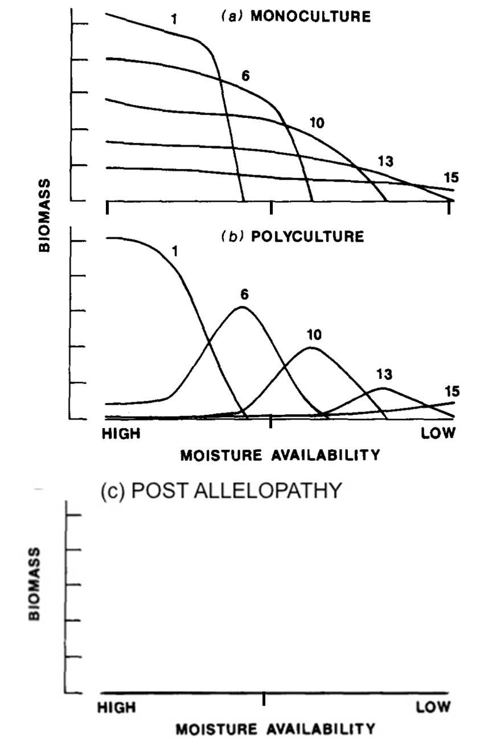

**Landscape pattern and disturbance regime**

*Instructions:*

When completing the following section, keep in mind that the Florida scrub landscape is very patchy. In addition to disturbance regimes, the physical template and biotic processes result in very different vegetation communities existing in close proximity to one another. As mentioned above, different vegetation communities interact differently with fire, so a single burn will not necessarily affect the whole landscape in the same way. For example, only communities which have accumulated enough litter to promote the spread of fire will burn. At Archbold Biological Station, land managers inventory the landscape after each prescribed burn to document how fire moved across the landscape. Figure 3 is an example of the resulting map. Note that the figure does not contain information about plant community types or microelevation, and therefore does not identify the specific communities burned. However, we can infer which communities are affected by different fire intensities based on what we know about how they respond to fire.

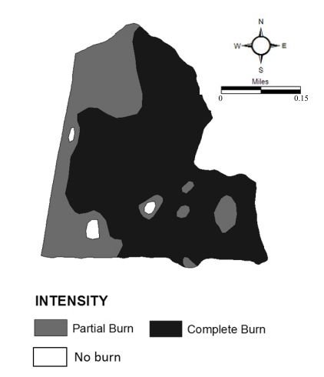

**Figure 3.** Map of fire intensity of a prescribed burn at Archbold Biological Station. Figure from Main, K. “Land Management: Preserving and Restoring Biodiversity.” 2010. Archbold Biological Station. Retrieved 8/16/2013 from <http://www.archbold-station.org/station/html/land/lmovr.html> © 2010 Archbold Biological Station

1. Turn to your neighbor and together make predictions about which communities (hammock, Rosemary scrub, scrubby flatwood, sandhill) likely existed in the regions of each different fire intensity.
2. Is there another way to assign communities to map of fire intensity? If so, what is it? Why can’t we be sure that of which community experienced which burn intensity?

**Synthesis**

*Instructions:*

By understanding how the drivers of pattern influence ecological processes, and in turn how processes influence landscape pattern, we can develop a more thorough understanding of landscapes, ecosystems, and communities. Synthesizing ecological concepts in a spatially explicit way can increase our understanding of the ecology of a system and allow us to make predictions about how a change in one pattern (or process) might influence other aspects of a system.

1. Using what you have learned about the drivers of landscape pattern, fill out the following table with traits of each community found in the Florida scrub.

|  |  |  |  |
| --- | --- | --- | --- |
|  | Physical Template | Biotic Interactions | Disturbance Regime |
| Rosemary Scrub |  |  |  |
| Sandhills |  |  |  |
| Scrubby Flatwoods |  |  |  |

1. Based on the information in your table, place the three communities on the graph of Figure 3-2 at appropriate soil drainage and fire return intervals.

Literature Cited:

Abrahamson, W. G., A. F. Johnson, J. N. Layne, and P. Peroni. 1984. Vegetation of the Archbold Biological Station, Florida: and example of the sourthern Lake Wales Ridge. Florida Scientist 47:209–250.

Main, K. 2010. Land Management: Preserving and Restoring Biodiversity. http://www.archbold-station.org/station/html/land/lmovr.html.

Richardson, D., and G. Williamson. 1988. Allelopathic effects of shrubs of the sand pine scrub on pines and grasses of the sandhills. Forest Science 34:592–605.

Smith, T., and M. Huston. 1989. A theory of the spatial and temporal dynamics of plant communities. Vegetatio 83:49–69.