ISSUES : FIGURE SET
Size, Niches, and the Latitudinal Diversity Gradient

John M. Grady^{1,2}, Quentin Read², Sydne Record¹, Phoebe Zarnetske², Benjamin Baiser³, Kalaina Thorne¹, and Jonathan Belmaker⁴
¹Bryn Mawr College, Bryn Mawr, PA, USA
²Michigan State University, East Lansing, MI, USA
³University of Florida, Gainesville, FL, USA
⁴Tel Aviv University, Tel Aviv, Israel
Corresponding author: John M. Grady (jgardymjgradym@gmail.com)

THE ISSUE
Species diversity generally increases in the tropics but testing theories that explain this phenomenon is challenging. Here we use body size to quantify niches in ecological communities and explore how species diversify towards the equator.

ECOLOGICAL CONTENT
Community ecology, latitudinal diversity gradient, niches, traits, body size

STUDENT-ACTIVE APPROACHES
Think-pair-share, hypothesis development, concept map, interpreting plots, informal group work

STUDENT ASSESSMENTS
Formulate hypotheses, minute paper, and concept map

OVERVIEW

WHAT IS THE ECOLOGICAL ISSUE?
One of the most general rules of biodiversity is that it increases towards the tropics. Birds, mammals, insects, fungi, and more — species diversity in all manner of form tends to increase at lower latitudes. Ecologists have long debated the origins of this pattern, known as the latitudinal diversity gradient. One influential hypothesis is that the warm and stable tropics support more niches, and this is why more species can be found there (MacArthur 1972, Schemske et al. 2009). Niches are the environmental conditions (e.g., temperature and food supply), and constraints (e.g., competition and pathogens), in which a population is stable or increasing (Hutchinson 1957). Although the niche is a classic ecological concept, measuring niches can be challenging. Linking population growth rate to features of the environment is difficult in the field, requiring detailed study that limits the numbers of species that can be examined. Recently, scientists have focused on a more tractable approach that can be applied both within and across entire communities. Researchers have used the functional traits of species—measurable characteristics linked to survival and performance—as proxies for niche dimensions (Kraft et al. 2008, Adler et al. 2013). One universal and ecologically important functional trait is body size. Although body size is a single trait, it directly affects or is correlated with a variety of traits affecting the niche, including diet, lifespan, growth and reproductive rates, and population size (Peters 1983). In this teaching issue, we demonstrate how body size variation in co-occurring species can be analyzed to test niche ideas of competition and diversity, using published work on North American small mammal communities (Read et al. 2018). Students gain experience linking data and plots from local sites to general concepts in ecology and global patterns of diversity.

FIGURE SET TABLE

Figure Set and  Ecological Issue | Student-active Approach | Cognitive Skill | Class Size/Time
Niches and body size distributions of small mammals | Think-pair-share and report out, drawing diagrams | Knowledge, comprehension, interpretation, analysis | any/moderate
Latitudinal gradients of size similarity | Think-pair-share and report out, making hypotheses | Knowledge, comprehension, interpretation, analysis | any/moderate
Spatial diversity: inferring cause from correlation | Think-pair-share and report out, concept map | Knowledge, comprehension, interpretation, analysis | any/moderate
Biotic interactions, community filters, and diversity | Think-pair-share and report out, concept map | Comprehension, application, analysis, synthesis | any/moderate

NICHES AND BODY SIZE DISTRIBUTIONS OF SMALL MAMMALS

- Purpose: To interpret graphical results, link figures to concepts, and examine how niches and body size patterns vary in space

- Teaching Approach: Think-pair-share

- Cognitive Skills: knowledge, comprehension, analysis

- Student Assessment: class participation, short answer, create diagram

FIGURE SET BACKGROUND

An important idea for understanding where species live and how they coexist is niche theory, in which species with similar biotic and abiotic requirements and tolerances, or similar niches, compete more strongly and are less likely to live in the same area. Conversely, species with different niches compete less and are more likely to coexist. Measuring niches and competition in the field can be challenging, but a new approach in ecology is to consider the overlap of traits that determine the niche of a species. In essence, trait overlap becomes a proxy for niche similarity. One such trait is body size, which affects species diet selection, metabolic demands and other aspects of the niche. We present figures of body size partitioning in small mammal communities in the United States. The distribution of individual body sizes for each species are shown for several communities and illustrate a general trend: overlap between species is lower in warmer environments, suggesting increased niche partitioning in more hospitable environments. This figure illustrates how traits can be linked to niches to understand coexistence, and how local patterns can change over large environmental gradients.

FIGURES

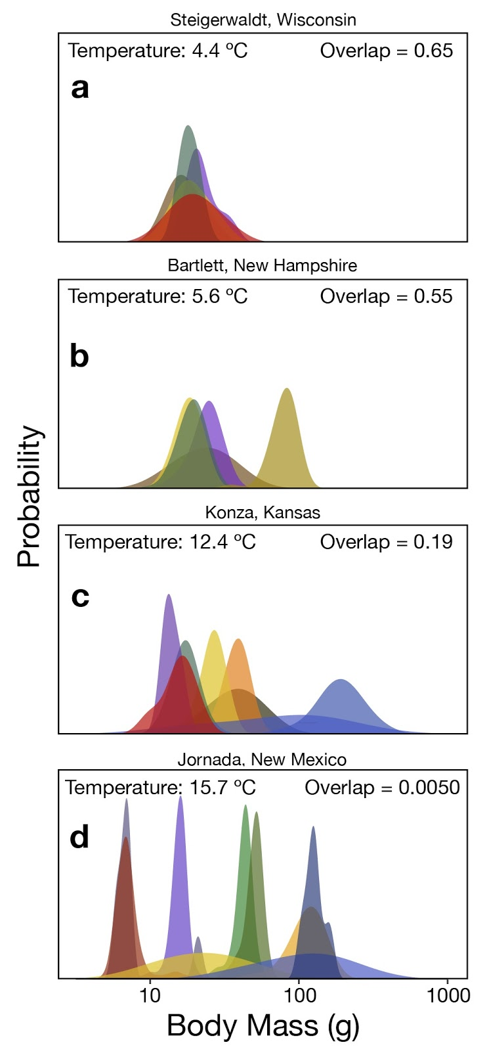
Figure 1. Small mammal body mass distributions. In a-d, body mass distributions of rodent species at four sites are shown, with the site name listed above each plot. Each species in a site is represented by a color. High values on the y-axis indicate common sizes, low values on the y-axis indicate uncommon sizes. The mean annual temperature is shown in the upper left of each plot. Each species’ body size distribution may overlap with another, with values ranging from zero (no overlap) to one (complete overlap). To characterize overlap among all the species for a given site, the average overlap of all pairs is shown in the upper right. Adapted from Read et al. 2018.
STUDENT INSTRUCTIONS

PRE-CLASS READING AND ACTIVITY

A Niche in Nature: Why Do Species Live Where They Do?
Take a walk in nature and look around. Depending on where you live, you might see tall trees, or grasses and shrubs, or perhaps small, prickly plants surrounded by bare patches of ground. On most continents there is a decent chance of spotting a squirrel, but not in Australia. Oaks and pines are common in the northern latitudes, but not near the equator or the southern hemisphere. Likewise, palms are common to tropical habitats, but generally are absent in the temperate zone. Why?

Perhaps some reasons come to mind. Australia is surrounded by saltwater and so squirrels never managed to disperse there. Dispersal is important. Many squirrels are particularly partial to acorns and seeds; proximity to certain foods or other resources might be relevant to where they are common. Parched deserts generally lack tall trees; a shortage of water resources might be an issue. If you were to plant a pine in a tropical garden, it would probably grow quite well. Yet pines are virtually absent from the tropical lowlands. Maybe the competition with tropical broad-leaved trees is too great? Palms, however, aren’t partial to freezing, perhaps they cannot physiologically tolerate the conditions of a cold winter.

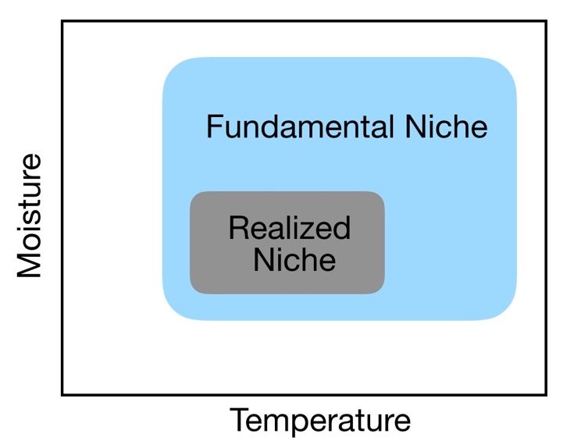
Physiological tolerance, resource availability, dispersal and competition — all these factors limit where a species lives. The dominant explanatory paradigm for why and where species live is called niche theory. Specifically, the niche is a species’ set of biotic and abiotic environmental requirements and constraints on its survival and reproduction — the conditions it can tolerate, the resources it requires — as wells as the limitations imposed by biological enemies and barriers to dispersal. Or to be a bit more technical, niches are the totality of biotic and abiotic variables in an environment in which the average population growth rate over time is ≥ 0 (not declining). Scientists distinguish between two forms of the niche. The fundamental niche is the first part of our definition: the environmental conditions, such as temperature or water requirements, required to sustain a population. The realized niche is the narrower set of conditions where a species can live that is limited by negative biotic interaction, such as competition or predation, and barriers to dispersal. If we were to focus on just temperature and moisture requirements, for instance, a plot of a species fundamental niche might look something like the blue plot to the right. For instance, if the species represented by this plot were a blue spruce, it would indicate that blue spruce could live in warm and wet habitats but are restricted to cooler and drier habitats (gray square) by some combination of competition, predation, pathogens or dispersal barriers. To restate our definition, the fundamental niche reflects where species could live in the absence of enemies and barriers, the realized niche generally reflects where species do live.

Niches & Diversity
Niches don’t just help us understand where a species lives, they can also help us understand how species coexist, an important topic in community ecology. In nature, resources like food or shelter are finite, yet the potential for population growth is exponential. As a result, competition for limited resources may be intense enough to cause local extinction. That is, if niches are too similar, the potential for local extirpation is high. On the other hand, reducing niche similarity can promote coexistence by limiting competition. For example, in Kruger National Park, South Africa, both white rhinoceros and black rhinoceros roam the savannas. Both rhino species are herbivores and potential competitors for finite resources, yet they generally live together without conflict. This is because white rhinos are grazers that eat grass, with wide square-shaped lips for chomping low ‘rhino lawns’, while black rhinos are browsers with curved, angled lips for plucking leaves from shrubs and small plants. These two species of rhinos differ in the food dimension of their niche, allowing them to coexist.

Coexistence promotes diversity, and some scientists believe niches can help us to understand one of the biggest topics in ecology: why diversity varies over space. For instance, scientists have long noted that diversity tends to increase towards the tropics, a pattern known as the latitudinal diversity gradient (LDG). Indeed, there are more species of trees in half a square kilometer of forest in Borneo, Indonesia than all the temperate forests of Europe, North America and Asia combined (Mittelbach 2017). Primates are almost exclusively tropical. More broadly, mammal, bird, amphibian, plant, fungi and reptile diversity all generally increase towards the equator and decline towards the poles.

There are many ideas to explain LDG, but a major one is that the tropics support or promote more niche specialists. That is, tropical environments have more organisms with narrow niches and limited competition, and so are better able to coexist. In the tropical rainforests of Malaysia there are 25 primates species; further north in the forests of Russia there are none. Malaysian primates specialize on eating fruits, seeds, insects or leaves year-round. Yet in the temperate zone many of these items are scarce in the winter, making such dietary niche specialization impossible.

Differences in food requirements are somewhat easy to conceptualize — though may be challenging to measure. However, niches have many more dimensions beyond food requirements, making it especially difficult to accurately track them all in nature. To really test this idea, we would need to examine population growth rates – to see if a population is not declining on average across time – with respect to a variety of environmental conditions. As a result, niche theories are hard to test. Do rainforests permit hundreds of tree species to co-occur because each species partitions the ‘tree niche’ into finer and finer slices — particular combinations of light, water, nutrients and pathogen resistance where they perform best? Some have suggested that niches are not particularly important within a natural community. For instance, Stephen Hubbell has argued that tropical trees are competitively equivalent, or ‘neutral’ (Hubbell 2001), and elements of chance govern local diversity. Which idea is right? There is still a great deal of debate.

Using Body Size to Quantify the Niche
A recent approach to measuring niches is to focus on species functional traits —measurable traits that are linked to survival and niche dimensions. Traits are easier to measure than niches and can be recorded for many species in a community. For instance, jaw size in fish affects their choice of prey; bigger jaws can swallow bigger prey. In trees, bark thickness governs a tree’s ability to withstand fire. Both of these features are related to perhaps the most universal and important organismal trait that can be readily measured: body size. Body size is closely linked to many other traits, including those that affect niche similarity. For predators, body size constrains the size of prey that can be eaten and this can reduce competition. Shrews eat earthworms, wildcats eat mice, and lions eat antelope; none of these organisms compete for food.

Body size affects many aspects of an organism’s niche, but for simplicity, let’s focus on how it affects dietary niche partitioning in animals. Body size affects (1) food quantity requirements; (2) food selection - i.e., food type or quality; and (3) tolerance of variability in food supply. There are costs and benefits associated with each of these aspects of the dietary niche that prevent one body size from outcompeting all other sizes.

Body size affects food intake requirements; larger species need more food (1). The dietary selection consequences are obvious with carnivores: foxes eat mice, but mice generally aren’t worth the trouble for lions. Size is also important for herbivores. Hares can survive on a small patch of grass and forbs in a savanna, but elephants may be forced to migrate during the dry season because there simply isn’t enough food to sustain their enormous appetites. The high food requirement is a cost of being large. However, large animals compensate to some extent by having larger jaws and digestive tracts. An elephant is capable of eating much more grass than a hare, and so as long as there is enough food to go around, it is not at a disadvantage.

This larger metabolic demand in elephants also affects the type of foods they eat (2). Virtually all herbivores prefer nutritious, low fiber plants — like new shoots — but these are in high demand and there isn’t always enough to go around. Small gazelle can afford to specialize on tender new shoots that are simply not abundant enough to satisfy a buffalo. Instead, buffalo will also eat low quality food like old grass that is mostly fiber: i.e., hard to digest cellulose and lignin. Mice can specialize on grass seeds that are nutritious but not abundant enough to satisfy a deer or boar. However, a deer can survive on lower quality food, because, despite being bigger, its cellular metabolism is lower. For this reason, a deer can afford to fill its digestive tract with lower quality food and extract less energy from it. Small herbivores generally avoid high fiber plants, relying on fruit and fresh shoots, but elephants will eat woody branches and bark. Thus, small size has the advantage of allowing animals to specialize on nutritious foods, while large size can allow animals to access and consume a greater variety of low quality items.

Finally, body size affects the ability of an organism to withstand variability in their food supply (3). As body mass increases, animals have more cells and so must eat more to sustain them. But as we mentioned, the metabolic rate per cell declines. This cellular metabolic rate corresponds roughly to heart rate, and it is why shrew and hummingbird hearts can beat 1,000 times a minute, and ours only ~70 times per minute. Why does this matter? Well, an elephant on an empty stomach can go without food much longer than a rabbit: its cellular metabolic demands are much lower, so a little percent of body fat goes a long way. Humpback whale mothers will travel half the globe to give birth in the tropics, where they are safe from orcas. There they will nurse their baby for several months without eating and live off of stored body fat. This strategy is only possible because of their low cellular metabolic rates. Large size has the advantage of increasing the time to starvation, so large species can rely on more variable food supplies. Overall, size-related differences lead to different costs and benefits regarding food type, amount, and frequency of eating that allow small and large species to reduce niche overlap and, thereby, coexist.

Body Size in Animals

In this exercise, we consider the effects of body size on the realized niche and diversity of a common mammal group in North America: the popular and charismatic rodent. The order Rodentia is the most diverse order of class Mammalia, representing ~40% of all mammal species. Rodentia includes chipmunks, beavers, hamsters, porcupines, flying squirrels, and the ubiquitous house mice. A key to rodent success is their ever-growing incisors (i.e., front teeth), which allow them to gnaw into tough items, from acorns and tree trunks to excavating tunnels. Rodents are common and their abundance and distribution can be monitored by trapping. In this study, we use data from scientists that have trapped and measured the body masses (i.e., weights) of various rodent species in different communities as part of a long-term monitoring program in the United States called NEON, short for National Ecological Observatory Network (http://www.neonscience.org/). NEON gathers data from observatories, satellites and field crews to monitor ecosystems and track how they change over time. Data collection protocols are standardized so that site to site results are comparable and general patterns of diversity and ecosystem function can be monitored and understood. Although NEON data do not span the entire globe, there is enough environmental variation in the United Sates that we can examine general spatial patterns of diversity and their relationship to the niche.

Quantifying the size niche

We would like to compare body sizes of different rodent species as a proxy for their niches, but there is a problem: each species does not have one specific size, so we cannot simply measure the difference between species. Just like humans, there is variation within a species (i.e., intraspecific variation). How, then, do we quantify this individual variation? One way is to quantify the probability of observing a certain size. In humans, the probability of randomly selecting someone of average height is much higher than selecting someone very short or very tall. More people are close to average height. You can see this in the adjacent plot. On the x axis, height increases from short to tall. On the y axis, the probability of observing that height in a randomly drawn person increases towards the average height and declines away from it. For probabilities, values on the y axis range from zero (never occurs) to one (always occurs). For instance, if the y value at 1.5 m was 0.1, this means 1 in 10 times a randomly sampled person of 1.5 m (4’ 11’’) will be observed.
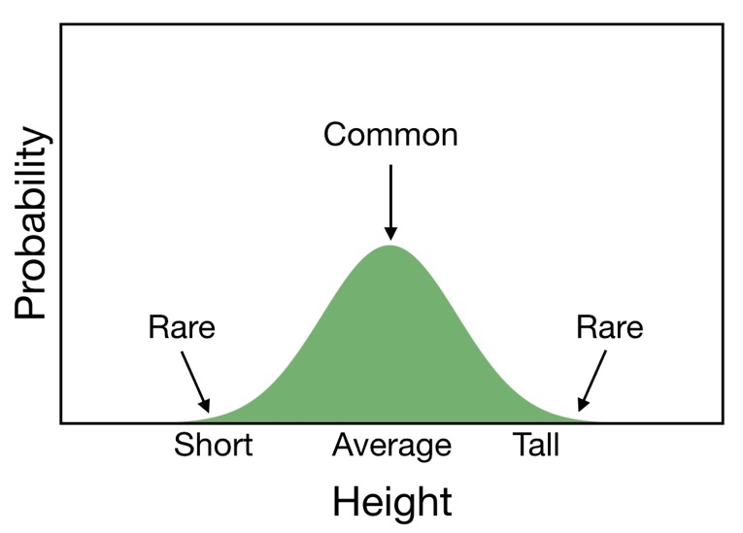
Thus, a probability distribution can be used to represent the probability of any given trait value for a species. In our case, that is body mass of a rodent population. A tall, skinny peak indicates there is a narrow band of variation—most individuals are close to the average size. A low, wide distribution indicates that there is a lot of variation and no size is particularly common.

Body Size Overlap
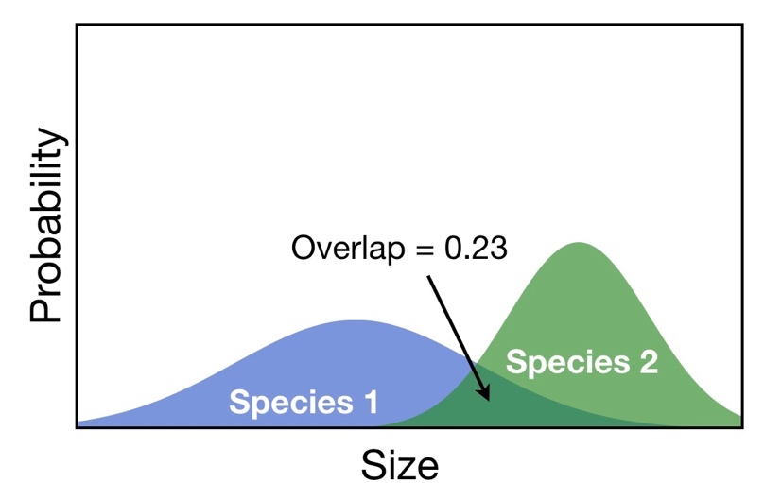
We are interested in how similar species are with respect to size. Body size overlap quantifies the similarity of two species’ body sizes using probability distributions. Like probabilities, overlap values can range from zero (no overlap) to one (complete overlap). Just by looking at the amount of visual overlap you can get an idea of the actual value. An overlap of 0.5 indicates that 50% of the area under the curve is shared with another species. In the figure to your right, overlap between two species is 0.23, or 23%. This method quantifies what fraction of individuals in two populations are actually the same size. By employing some statistical methods, we can convert sampled sizes of a species into a probability distribution, and then calculate the overlap in distributions between two sizes. The main idea is this: the more overlap in size, the more similar in size and the more likely two species are to share a niche and compete.

We just discussed how to measure the similarity of two different species. But how would we characterize the niche similarity of a whole community? Suppose we have ten species of mice in a desert, all eating seeds and insects. To quantify average overlap between all ten species, we calculate the overlap for each pair, and then the average of these values. This provides a general metric of trait and niche similarity for a community.

Now take a look at the plots in Figure 1 and read the caption carefully. Note the x and y axes and think about what a point in this graph would mean based on the axes. Go through the first step independently, then with a partner discuss your answers. For all subsequent steps think through the answers independently then discuss with your partner. You will have an opportunity to explain your answers to the class.

Step One: First, a quick review of concepts. What is a niche? How is the fundamental niche different than a realized niche? How can differences in body size reduce niche overlap?

Step Two: Describe the axes and what they show. What do the x and y axes represent? What do the different colors mean? Why are some curves tall and narrow and others flat and wide? What does the value in the upper right corner signify? Compare the four plots. What is the difference between them? Is there a trend? What seems to predict the different patterns for each plot?

Step Three: Look at the reported values of overlap. What do they mean? How does a value of 0.55 from Bartlett, New Hampshire differ from another with 0.19 from Konza, Kansas? For Figure 1c, estimate the overlap between the two blue distributions of large species.

Step Four: Try to interpret the plots in Figure 1. What is the significance of overlapping curves — what does this tell us about niches? What is the trend between plots? Suggest a hypothesis for what this trend signifies and why it might be occurring. Remember that a good hypothesis involves a plausible mechanism that would predict the observed pattern.

Post-class assessment: Please complete the following questions for homework.

1. Imagine a community with three species: A, B, and C. Assume the overlap value for one pair is 0, another is 0.5, and a third is 0.25, what is the significance of these different values? Draw a schematic similar to Figure 1 for this community. Write the average overlap in the upper righthand corner. Remember to label all axes and write a figure caption.

2. What is a major assumption of this study regarding niche occupation? Can you think of an example where different species of rodents are the same size, but don’t compete?

3. Suppose there are some similarly sized rodents that don’t compete in this study, but, on average, similar sized rodents tended to compete more than differently sized species. Would this kind of study still be informative? Could it still provide evidence for size-based niches?

NOTES TO FACULTY

This exercise is appropriate for freshman to sophomore level biology or environmental studies majors. This work may be a useful follow-up for lectures on competition, coexistence or niches, but background information on competition, niches and body size are also provided. Students can read the instruction section on their own, such as the night before, or be given a mini-lecture summary before or after reading the introduction, depending on the background level of understanding. Students should have some familiarity with principles of species interactions, such as competition, and a basic understanding of frequency/probability distributions, although the description provided here may be adequate (see Resources links). Depending on the students’ backgrounds, they may need help understanding a probability distribution. Students should recognize that one entity, such as a mouse, can have two properties that can be represented on a graph (such as a mass and probability of being encountered). Intuitive examples of how body size affects competition are provided further below. Explanations and examples are provided in the Student Instructions but can be supplemented by the instructor if desired.

A good example of probability distributions that students can relate to are their own body sizes — e.g., the distributions of body height in a classroom. Some heights are more common than others, and so will be counted more frequently in a sample. If we counted all the heights in a school, they would form a frequency distribution, with some sizes more commonly observed than others. A probability distribution is similar, but counts are instead converted to probabilities, representing the probability of observing a particular size from a randomly selected student. Students should understand that probabilities occur between zero (never occurs) and one (always occurs) and that the sum of all values in a probability distribution is one. The exact value for a given point is less important than the general shape — which sizes are common and which sizes are rare?

Although the figures may be unfamiliar to students, they should be intuitive once students get a handle on how the plots work. It may be worthwhile drawing a few examples of overlap on the board. Two species distributions that do not overlap at all have a value of zero, complete overlap is a value of one (equivalent to 100% overlap), and 50% overlap is 0.5. A student should be able to eyeball a distribution and see roughly how much two distributions overlap. Note that the two distributions must have the same area, even if their shape is different, as this is an inherent property of probability distributions. The average overlap for a whole community is the average of all pairwise combinations.

Once it is clear students understand the basics of probability distributions and size overlap, we suggest letting students grapple with the figures for several minutes before assisting them. Alternatively, the instructor could allow the students to work through the instructional text and try to understand the concepts on their own and through dialogue with their partner. The instructor can circulate amongst student pairs to get a sense of how well students understand the plots, and what the sticking points are. These issues can then be addressed before the whole class.

Answers and assessment
Students can also be assessed by their contributions during the exercises, as well as short answers from in-class steps and the post-class assignment. We suggest think-pair-share exercises for each step, as this approach gives students the space to come up with answers independently (‘think’) and then share in a lower-stakes environment with their peer partner (‘pair’), thus leading to higher response rates in a whole-class discussion (‘share’). Students can volunteer or be called upon to report their findings to increase class engagement.

Answers to all questions are provided below.

Step One: What is a niche? How is the fundamental niche different than a realized niche? How can differences in body size reduce niche overlap?

The niche is the set of biotic and abiotic resources and conditions that determine where a species or population can live. The realized niche is generally smaller than the fundamental niche, reflecting the additional effects of negative biological interactions and dispersal barriers that limit where a species can live.
Greater size overlap implies greater niche overlap and greater competition. Body size affects three dimensions of diet - quantity, type, and variability in food supply. Body size is associated with advantages and disadvantages for each dietary dimension that promote coexistence between species of different sizes.

Step Two: Describe the axes and what they show. What do the x and y axes represent? What do the different colors mean? Why are some curves tall and narrow and others flat and wide? What does the value in the upper right corner signify? Compare the four plots. What is the difference between them? Is there a trend? What seems to predict the different patterns for each plot?

The x axis is body mass, the y axis is the probability of occurrence, which shows the relative commonness or rarity of individuals at a given mass. Tall, skinny curves represent distributions where there is relatively little variation in size—most individuals are close to the average mass; wide distributions are the opposite. The reported overlap is the average overlap of all species pairs.

Step Three: Look at the reported values of overlap. What do they mean? How does a value of 0.55 from Bartlett, New Hampshire differ from another with 0.19 from Konza, Kansas? For Figure 1c, estimate the overlap between the two blue distributions of large species.

A value of 0.55 indicates an almost threefold higher overlap in body size distributions at Bartlett compared to 0.19 observed at Konza. Therefore, the body size distributions of rodent species are much more similar at Bartlett. The overlap in 1c is ~0.3 for the two blue colored species.

Step Four: Try to interpret the plots in Figure 1. What is the significance of overlapping curves — what does this tell us about niches? What is the trend between plots? Suggest a hypothesis for what this trend signifies and why it might be occurring. Remember that a good hypothesis involves a plausible mechanism that would predict the observed pattern.

There is a trend towards less overlap in warmer habitats. Generating a relevant hypothesis is not necessarily obvious to students at this point. However, it offers an opportunity for students to brainstorm and creatively engage with the material and may be useful as an interactive class exercise. It also provides an opportunity to introduce the concept of hypothesis generation and distinguish between a null hypothesis. In this case, the null hypothesis is that species size distributions are random and/or there is no meaningful trend with temperature. The alternative hypothesis is that body size distributions are non-random and shift with temperature for some ecologically plausible reason (such as higher competition in warm temperatures).

Post-class assessment.
Question 1. Imagine a community with three species: A, B, and C. Assume the overlap value for one pair is 0, another is 0.5, and a third is 0.25, what is the significance of these different values? Draw a schematic similar to Figure 1 for this community. Write the average overlap in the upper righthand corner. Remember to label all axes and write a figure caption.

The average overlap is 0.25.

Question 2. What is a major assumption of this study regarding niche occupation? Can you think of an example where different species of rodents are the same size, but don’t compete?

The major assumption of this study is that body size is a meaningful predictor of niche similarity. Of course, this is not always true. Obviously, similarly-sized herbivores and carnivores would not compete for food (but might compete for water, shelter or other resources). Our study limits niche analysis to rodents, which tend to be generalists eating a variety of plant matter, supplemented by the occasional insect. But some rodents, like tree squirrels, might focus on acorns, and others, like voles, might specialize on plant shoots and roots. Tree squirrels also feed in the day while other similarly sized rodents, such as rats and flying squirrels feed at night, reducing niche overlap.

Question 3. Suppose there are some similarly sized rodents that don’t compete in this study, but, on average, similar sized rodents tended to compete more than differently sized species. Would this kind of study still be informative? Could it still provide evidence for size-based niches?

As the examples in question 2 indicate, body size is not the only predictor of competitive overlap. Most patterns in nature have multiple causes, so it would be unusual if one predictor could explain all the variation. If temperature is an important predictor of competitive similarity and can be mechanistically linked to diversity with theory and data, then it can regarded as an important factor worthy of study.

A note on logarithms. Attentive students may notice that that the x axis for our probability distributions in Figure Set one are logarithmic. Each tick mark indicates an increase by a constant proportion; in our case, a tenfold increase for each tick mark: from 10 to 100 to 1000 grams. Log distributions are commonly observed in nature when multiplicative processes lead to proportional shifts. For instance, growth, which involves the doubling of cells per division, is a multiplicative process. Although logs may be unfamiliar to people, proportional changes captured by logarithms are actually closer to how people register how loud sound is or assess distance (Varshney & Sun, 2003).

Proportional changes are important for niches, too. Larger predators tend to eat larger prey, reducing niche similarity, but how much larger does a predator have to be before its diet no longer overlaps with a smaller predator? A 50 g shrew that eats earthworms does not overlap in diet at all with a 5 kg wildcat specializing on mice. Is ~5 kg the right amount to differentiate diet choice? A 155 kg tiger and 150 kg Indian lion could be in competition for food —both eat large ungulates. But a 0.5 g beetle will have a very different diet than the 50 g shrew. What is more relevant in all these cases is the proportional difference in mass, not the arithmetic difference. A 50 g shrew is 100 times larger than the beetle and 100 times smaller than the wildcat. On a log plot, these are equal distances. For these and other reasons, logarithmic transformations are very common when studying nature.

More on niches. The ‘niche’ is an old and important concept in ecology. Niches define why species live where they do, and how species coexist. Despite its conceptual utility, its meaning is somewhat nebulous: there are different definitions of niches, and niches are generally hard to measure. The definition presented here — a species’ biotic and abiotic requirements for sustained existence — is the most common and is sometimes referred to as the Hutchinsonian or Grinnelian niche. Other, more ‘Eltonian’ definitions may emphasize a species impact on the environment rather than its requirements. For instance, a beaver may require a supply of edible trees and water for survival, but its influence on the ecosystem includes creating dams and temporary ponds.

LATITUDINAL GRADIENTS OF SIZE SIMILARITY

- Purpose: To practice analyzing graphical data; to use data to generate or refine hypotheses; to link local patterns to broader spatial trends.

- Teaching Approach: Think-pair-share

- Cognitive Skills: knowledge, comprehension, interpretation, analysis

- Student Assessment: class participation, generating a hypothesis, short answer

FIGURE SET BACKGROUND

The goal of this exercise is to link concepts embedded in local patterns to larger trends in nature. In particular, we want to extend concepts of niches to larger spatial trends of diversity. Perhaps the most well studied — and debated — trend in spatial diversity is the latitudinal diversity gradient (LDG), in which species diversity increases towards the tropics. There are many hypotheses for why the LDG occurs, and it is likely that more than one mechanism is at work. There are at least two niche-based hypotheses for the LDG. First, lower-latitude environments have milder winters, organisms are not subject to harsh freezing conditions, and, as a result, food and shelter is more available year-round. From a niche perspective, this implies that there is more ‘niche space’ towards the tropics, i.e., more available food/shelter niche dimensions in the tropics because the environment is not so restrictive. For instance, fruit-eating monkeys can survive in tropical forests that produces fruit year-round, but not in a temperate forest where fruit production dwindles during the winter. Mangrove trees, which don’t tolerate freezing, are widespread near the equator, but quickly disappear outside tropical zones.

Another consequence of more benign environmental conditions in the tropics is that biological interactions may become more important than abiotic conditions. Milder winters permit more species to live in a habitat, increasing the opportunities for biological interactions. Thus, competition, predation, disease and mutualism may become stronger. From a niche perspective, increased competition may promote further specialization, lower niche similarity, and lower trait overlap. Thus, greater niche partitioning in the tropics may play a role in the higher diversity of species found there compared to temperate areas.

In this exercise, we examine patterns of size overlap across the United States and consider their implications for biodiversity. Although the United States is temperate, it spans a large spatial area with considerable environmental diversity, and a latitudinal diversity gradient is observable for many taxa (Jenkins et al. 2015).

FIGURES
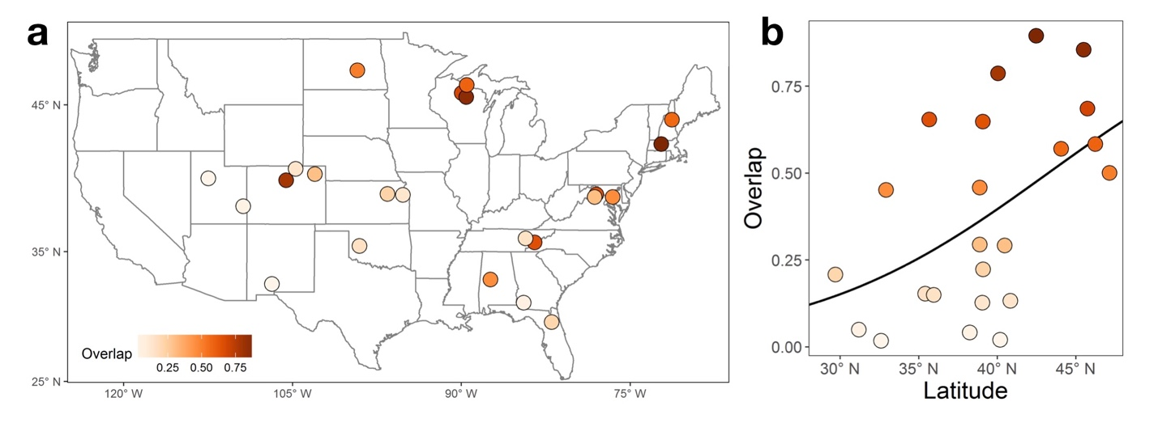

Figure 2. Patterns of mammal size overlap in the United States. In a, a plot is shown of all sampled sites, with the average pairwise overlap of body mass of each community indicated by color. In b, average body mass overlap is plotted against latitude to reveal the spatial trend (r² = 0.28, p = 0.004). In this regression, the data is logit transformed because overlap values are bounded between 0 and 1. Data in 2a-b comes from the National Ecological Observatory Network (NEON). Adapted from Read et al. 2018.

STUDENT INSTRUCTIONS

Connecting local studies to global patterns
Scientists often study a small, tractable system in order to understand larger patterns and processes. For instance, geneticists may study fruit fly genes not to better understand fruit flies per se, but because they are an easy-to-work-with model of genetics, and scientists can build on previously published work that used fruit flies. Understanding fruit fly genetics is a doorway to understanding animal genetics, including humans. In the same way, we are interested in putting our study in the context of broader conceptual issues. Do species partition (divide) niche space and does this permit greater diversity? Does niche partitioning increase towards the tropics and can this help explain spatial patterns of diversity that have fascinated ecologists for centuries?

Latitudinal Diversity Gradient
Perhaps the most recognized and debated spatial pattern of diversity is the latitudinal diversity gradient (LDG), in which diversity increases towards the tropics. For instance there are more species of trees in half a square kilometer of forest in Borneo, Indonesia than all the temperate forests of Europe, North America and Asia combined (Mittelbach 2017). Why is this? There are many ideas. Scientists have hypothesized that the LDG is caused by higher tropical productivity, faster metabolic and evolutionary rates, greater seasonal stability, or greater long-term climatic stability in the tropics (e.g., even during the Ice Ages, no glaciers formed in tropical regions), among other factors. All of these may play a role, and this is still an active area of research.

Other hypotheses explaining the LDG stem from niche theory. Lower-latitude areas tend to have milder winters, with less freezing that can damage cells and kill organisms. As a result, many species that cannot tolerate freezing are excluded from temperate zones. This may be one explanation for why the tropics contains more varieties of species. Species that do not tolerate freezing (e.g., palms, vines, bromeliads, mangroves) flourish in the tropics, but dwindle elsewhere. Not only does plant variety increase in the tropics, but all the animals, fungi and bacteria that depend on these plants have more opportunities for food and shelter. For instance, rainforest frogs can lay their eggs in bromeliads that hold water, away from predators. This option simply doesn’t exist in most temperate forests. In the tropics, there are new niches to occupy. In effect, the total niche space of a community increases as the variety of life increases.

Conversely, many temperate species may grow well in the tropics, but cannot tolerate the competition. For instance, consider the firs and spruces that live in the boreal forests of Canada. Many of these species would grow perfectly well if planted further south in the United States. Nonetheless they likely could not survive the low light and deadly pathogens of a wild warm temperate forest. For this reason, some have argued competition for resources and pathogen pressures are much stronger towards the tropics. In the Canadian summer, transplanted tropical trees might outgrow and outcompete neighboring spruce and firs. Given enough time in summer-like conditions, spruce and firs would probably go extinct. But winter comes every year, causing ice crystals to form in the leaves of tropical trees and damaging the vascular channels that transport water and sugar through its body. In effect, freezing conditions are an abiotic ‘filter’ that prevents many potential competitors from occurring in high latitudes. While competition still occurs, many of the selective pressures may be acting on traits that help high latitude trees survive icy conditions.

With less physiological stress in the tropics, there is a more constant supply of food and shelter throughout the year. This steady supply of resources allows many species to specialize. For instance, monkeys that require fruit or birds that prefer insects can feed year-round in the tropics. In plants, there is evidence that tropical trees germinate at different times of the year, reducing overlap during this vulnerable phase of development (Usinowicz et al. 2017). Specialists have narrower fundamental niches — or narrower niche widths — and so available niche space can be divided up into finer, non-overlapping slices and support more species. More niche space and smaller niches may permit more species in the tropics.

Some scientists have theorized that increased competition, predation, and pathogens in the tropics also promotes specialization to deal with these biological challenges. In the warm, damp conditions of a rainforest, deadly specialist fungi abound, limiting the abundance of a particular tree species, but making room for other species. Conditions are so optimal for growth that plants grow on top of other plants. Moss, ferns and bromeliads grow on tree branches. Clinging vines threaten to block out the light to canopy trees. Some trees fight back. They may respond by producing sugary secretions (‘nectaries’) that attract ants which protect their sugar supply by pinching and slicing encroaching vine tendrils. Palms periodically shed their fronds, ridding themselves of vine-infested leaves. An arms race between competitors or predators and prey promotes the evolution of more and more specialized niches in warm and wet habitats, increasing diversity.

A Spatial Signal of Niches in the United States?
We have now considered how niche characteristics might change with latitude, and why this may promote diversity towards the tropics. In this next exercise, we consider patterns of niche similarity and body size overlap in rodents across the United States. In particular, we ask: is there evidence for greater niche partitioning of body size at lower latitudes? Although the United States is temperate, it spans a large spatial area with considerable environmental diversity, and a latitudinal diversity gradient is observable for many taxa (Jenkins et al, 2015). Examine the map and scatterplot in Figure 2. Answer each question by yourself first and then discuss with your partner. Be prepared to share your answers with the class.

Step One: For Figure 2, read the caption and examine the x and y axes and color bar carefully. What do they represent? What do the values represent?

Step Two: Examine the darkest red values in 2a, and then circle (or identify) the corresponding values in 2b. What is the general trend?

Step Three: What might be causing the trends observed in Figure 2? Bear in mind that latitude itself is not a biologically meaningful cause. What environmental factor(s) correlated with latitude could be driving this pattern?

Post Class Assessment: Please complete the following questions for homework.

1. The overlap regression line bends in the plot so that the y value of the line never falls below 0 or exceeds 1 even as x increases to 90° N or declines to 90° S. Why do the authors choose such a functional fit? Contrast this with an ordinary linear fit (straight line).

2. Generate two separate hypotheses about what could be driving the pattern observed in figure 2b.

NOTES TO FACULTY

The questions in this exercise are not technically difficult, but require students to understand the questions, concepts, and draw conclusions. Depending on students’ familiarity with scatterplots, some introduction may be necessary. Students unfamiliar with analyzing scatterplots will likely struggle at first. In this case, we suggest a quick introduction or refresher on scatterplots and then allow students to wrestle with the plots for a few minutes before checking on their progress. We report r² and p values, and instructors may want to familiarize these statistical concepts with students first. Briefly, these are measures of how well the fitted line captures the data trend and variation. If the r² = 0 there is no explanatory power; r² = 1 perfectly describes the pattern and the line will go through all points. p values < 0.05 are considered statistically significant. A regression line is preferred to plotting the mean of y.

Students can be called on to present their answers, which the class can discuss. Alternatively, if all of the figure sets in this exercise are worked on in a longer class or set of classes, then the instructor could rotate through groups of pairs of students to present their answers to ensure that everyone in the class has a chance to speak. This, of course, would only be feasible in a smaller class. Answers from classes exercises can be handed in for a grade. A post-class assessment involving hypothesis generation and statistical analysis is also provided.

Answers:

Step One: For Figure 2, read the caption and examine the x and y axes and color bar carefully. What do they represent? What do the values represent?

In Fig 1a, the x and y axes represent longitude and latitude, respectively. In Fig. 1b, the x and y axes represent latitude and average, site-level overlap in body size, respectively.

Step Two: Examine the darkest red values in 2a, and then circle (or identify) the corresponding values in 2b. What is the general trend?

Dark red represents high site-level overlap. The darkest circles in 2a will have the highest body size overlap in 2b for their respective latitudes. The general trend is higher overlap at higher latitudes.

Step Three: What might be causing the trends observed in Figure 2? Bear in mind that latitude itself is not a biologically meaningful cause. What environmental factor(s) correlated with latitude could be driving this pattern?

Ambient temperature and seasonality are associated with latitude; the former declines with latitude, the latter increases. Other plausible answers may exist.

Post Class Assessment:

Question One: The overlap regression line bends in the plot so that the y value of the line never falls below 0 or exceeds 1 even as x increases to 90° N or declines to 90° S. Why do the authors choose such a functional fit? Contrast this with an ordinary linear fit (straight line).

The minimum overlap in size between species is 0; the maximum is 1. Therefore, the regression fit cannot exceed those values and bends near these boundaries. A straight line, however, would incorrectly imply y values greater than 1 or less than 0 are possible. Note that a linear regression of logit-transformed data was used, which would appear straight if the y axis values were logit(y). A logit transformation converts data following a log sigmoidal (s-shaped) logistic function into a straight line.

Question Two: Generate two separate hypotheses about what could be driving the pattern observed in figure 2b.

Hypotheses relating to ambient temperature or seasonality (which are correlated) could explain the latitudinal and thermal trend.

SPATIAL DIVERSITY: INFERRING CAUSE FROM CORRELATION

- Purpose: To practice interpreting graphical data; to infer causal pathways; to practice assessing hypotheses

- Teaching Approach: Think-pair-share

- Cognitive Skills: knowledge, comprehension, interpretation, analysis

- Student Assessment: class participation, concept map, short answer

FIGURE SET BACKGROUND

This figure shows the relationship between body size overlap, environmental temperature and species richness in small mammals. Correlations exist between these variables, but correlation of course does not imply causation. However, stronger correlations are generally more indicative of causal relationships than more weakly related variables. Here we ask, what is responsible for changes in species richness (number of species) per site? In particular, does temperature directly predict richness, or does temperature indirectly predict richness by acting on trait overlap? To disentangle the relationships between these variables, we use a statistical tool called path analysis that shows the most likely relationships between body size similarity, environmental temperature, and community richness. These relationships can be observed from the scatterplots and path diagram. Students will consider how plotting and visualizing data can help us understand the mechanisms generating biodiversity.

FIGURES
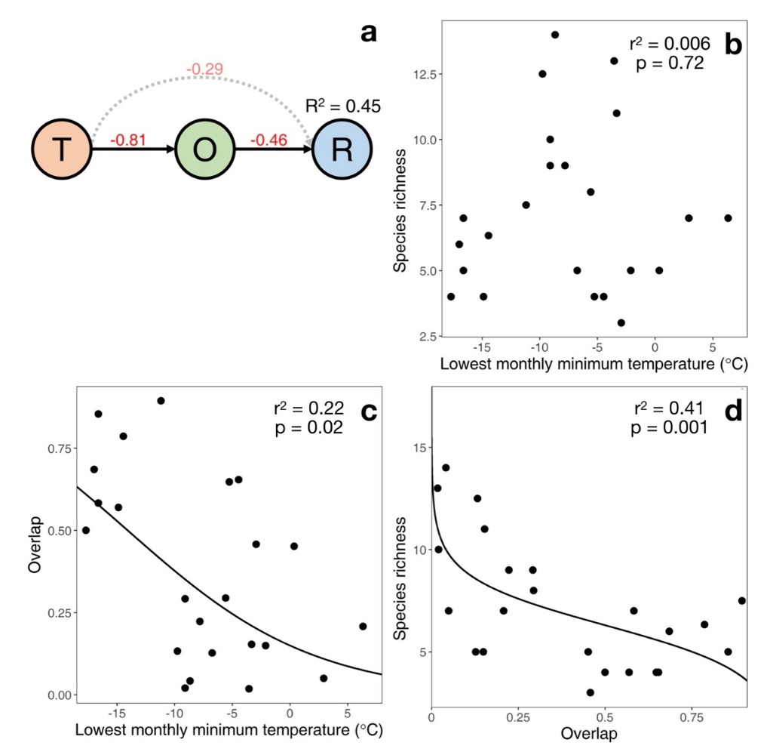
Figure 3. Size overlap, richness and temperature. In a, we show the best supported relationship from path analysis, where T is the minimum temperature of the coldest month, O is the average pairwise overlap, and R is community richness. The arrows indicate the directions and strengths of relationships between variables, with the best supported relationships indicated by solid lines. The red text indicates if correlations are positive or negative, and their strength (where -1 is strongly negative, 0 is no relationship, and 1 is strongly positive). In b-d, the bivariate relationships between T, O, and R are shown using linear regression, where overlap is logit transformed. p values less than 0.05 are significant; r2 describes the variation described by the regression fit, ranging from 0 to 1. Adapted from Read et al. 2018.

STUDENT INSTRUCTIONS

In Figure 2, we observed that body size overlap increases at higher latitudes. However, latitude itself is not very meaningful. It is just a measure of a site’s location on Earth. What environmental drivers might be responsible for this trend? Let’s consider Figure 3. This has 4 panels. We have measured or calculated average community overlap, minimum temperature and community richness. How do these variables relate to each other? Does temperature predict richness directly, or does temperature predict overlap, and overlap predicts richness? Are these relationships positive (when one increases, the other increases; when one declines the other declines) or negative (when one increases the other decreases and vice versa)? The direction of the arrows indicates which is a likely cause and which is the effect, with the effect being at the end of the arrow. All the plots are related. Look carefully at them and the caption and try to understand what they are telling us. First, answer each step on your own and then with your partner, before moving on to the next step.

Step One: Looking at Figure 3a, what is causing/predicting what? Describe the supported causal relationships between all three variables. Which variables are most highly correlated? Are their relationships positive or negative, and what does that mean?

Step Two: Figures 3b-d depict scatterplots of different variables. What is a scatterplot? What does a single point represent? What is the relationship between overlap, temperature, and richness? Are variables positively correlated, negatively correlated, or uncorrelated? Of the three correlations shown, which variables have the strongest correlations?

Step Three: In Figures 3-d, what is the predicted species richness for a community overlap value of 0.75? What does this mean?

Step Four: Consider the hypothesis you created for Figure 2, in which overlap changed with latitude. Based on Figure 3, what environmental factor do the authors indicate is important to explain patterns of overlap and richness? Why should this affect competition and body size overlap? Can you think of an environment where competition is not as important as some other factors?

Post Class Assessment: Please complete the following questions for homework.

1. Fig. 3a shows a best supported pathway for how the variables are related. However, if we were to reverse the direction of all the arrows, this path diagram would have equal statistical support. Draw this pathway and explain what it would imply. Explain why the authors did not seriously consider this alternate pathway.

2. Instead of temperature, overlap, and richness, imagine a system with precipitation, overlap, and richness, where higher precipitation leads to richness and higher richness leads to lower overlap. Draw this figure, affixing a + or – to each arrow indicating increases or decreases. Compare this figure with the one we see in Fig. 3a.

NOTES TO FACULTY

This lesson plans tries to understand the relationships between correlated variables. In this case, correlations between temperature, richness and overlap all exist. What is the proper causal sequence? We use the statistical tool called path analysis to test if that hypothesized mechanistic pathway is supported by our data (see http://crab.rutgers.edu/~goertzel/pathanal.htm for more description). The students should understand how to look at a scatterplot and tell if the relationship between variables is positive, negative, or neutral, and highly predictive or poorly predictive. Assessments include a short answer and path diagram suggested under post-class assessments. Class participation and answers to figure set steps can also be used for assessment.

Below we include answers to in-class questions and the post-class assignment.

Step One: Looking at Figure 3a, what is causing/predicting what? Describe the supported causal relationships between all three variables. Which variables are most highly correlated? Are their relationships positive or negative, and what does that mean?

The path analysis supports the hypothesis that temperature causes overlap and overlap causes richness. More specifically, an increase in temperature leads to a decline in overlap, which leads to an increase in richness. The strongest correlation is between temperature and overlap (r = -0.81); this indicates that as temperature increases, overlap declines. The weakest relationship is between temperature and richness.

Step Two: Figures 3b-d depict scatterplots of different variables. What is a scatterplot? What does a single point represent? What is the relationship between overlap, temperature, and richness? Are variables positively correlated, negatively correlated, or uncorrelated? Of the three correlations shown, which variables have the strongest correlations?

Scatterplots show the relationship between two continuous variables, x and y. In our case, each point represents a site with a temperature and an average overlap value. In b, there is no correlation, in c there is a negative correlation (when temperature increase, overlap declines), and in d there is negative correlation (when overlap increases, richness declines). These same relationships are shown in Fig 3a, indicated by arrow signs and correlation values. Note the correlations in Fig 3a are also weighted by other predictors, so they are similar but not identical to $\sqrt{r^{2}}$ of the bivariate plots.

Step Three: In Figures 3-d, what is the predicted species richness for a community overlap value of 0.75? What does this mean?

About 5 or 6. If we were to examine a site that had an average body size overlap of 0.75, our best prediction of richness for this site would be 5 or 6 rodent species.

Step Four: Consider the hypothesis you created for Figure 2, in which overlap changed with latitude. Based on Figure 3, what environmental factor do the authors indicate is important to explain patterns of overlap and richness? Why should this affect competition and body size overlap? Can you think of an environment where competition is not as important as some other factors?

From the plots of temperature, the authors identify temperature as an important environmental factor responsible for changes in species similarity in size. Warm temperatures may promote the relative importance of biotic interactions like competition, leading to less niche overlap. In extreme environments, like deserts or tundra, competition may be less important than water limitation or freezing.

Post-class assessment

Question one. Fig. 3a shows a best supported pathway for how the variables are related. However, if we were to reverse the direction of all the arrows, this path diagram would have equal statistical support. Draw this pathway and explain what it would imply. Explain why the authors did not seriously consider this alternate pathway.

Correlations between two variables do not indicate which is the cause and which is the effect. Thus, it is equally statistically plausible that richness causes overlap, and overlap causes temperature (richness –> overlap –> temperature). However, biologically speaking, we know that overlap will not cause environmental temperature. Therefore, the only biologically plausible relationship supported by data is temperature –> overlap –> richness; that is, a reversal of the direction of causality.

Question two. Instead of temperature, overlap, and richness, imagine a system with precipitation, overlap, and richness, where higher precipitation leads to richness and higher richness leads to lower overlap. Draw this figure, affixing a + or – to each arrow indicating increases or decreases. Compare this figure with the one we see in Fig. 3a.

Precipitation (-) –> Overlap (-) –> Richness

BIOTIC INTERACTIONS, COMMUNITY FILTERS, AND DIVERSITY

- Purpose: to communicate ecological ideas through schematics

- Teaching Approach: think-pair-share

- Cognitive Skills: knowledge, comprehension, interpretation, application, synthesis

- Student Assessment: class participation, concept map

FIGURE SET BACKGROUND

In the previous exercises, students observed empirical patterns and tried to link them to ecological concepts like niche partitioning, competition and diversity. In this exercise, students will think more directly about theory. They will consider how niche theory can be understood and communicated with schematics — data-free figures that depict scientific ideas. Although schematics are often introduced early in a scientific publication, they represent a level of abstraction that is not always readily accessible to newcomers, which is why we order this figure set last. Students will learn how ideas are often best communicated visually, and how visual communication opens up opportunities to explore and test hypotheses.

Here we focus on the role of biotic and abiotic forces or ‘filters’ that limit where species live. These filters have important roles in excluding, or filtering out, some traits, while allowing other in. Species with filtered traits will be excluded from an area. Examples of environmental or abiotic filters include freezing temperatures, drought, or fire; all these features will exclude many species that are not able to tolerate them. For instance, trees with thin bark are often excluded from areas with frequent fire that can damage stem tissue. Biotic filters include negative interactions from other organisms, such as competition and predation. For instance, the destructive mountain pine beetle in western North America limits the range of the lodgepole pine in warmer habitats where it occurs, an example of a biotic filter. Conversely, the northern range of the mountain pine beetle is limited by cold winters, an abiotic filter. Biotic filters are often thought to be more important in benign environments, like tropical rainforests with no freezing or water stress, and can contribute to diversity by encouraging specialization. Conversely, environmental filters are expected to be more significant in more extreme environments, such as deserts, mountain tops, regions that experience freezing, hypersaline lakes, or habitats with high sand or metal content in soils.

What is the effect of biotic and abiotic filters on niches? If intense competition or a stable supply of food promotes specialization, what happens to a species niche? It may become narrower (i.e., its niche width declines). From a community perspective, more hospitable environments can encourage a greater variety of life forms with different requirements. Northern boreal forests have limited plant and insect diversity; as a result, insectivorous and frugivorous bats are rare or absent. Those niches aren’t available because the overall niche space is lower. Thus, niche characteristics can change for individual species and for the community as a whole. Although niches are hard to directly measure, we focus on traits as proxies for describing how niches may change with temperature.

FIGURES

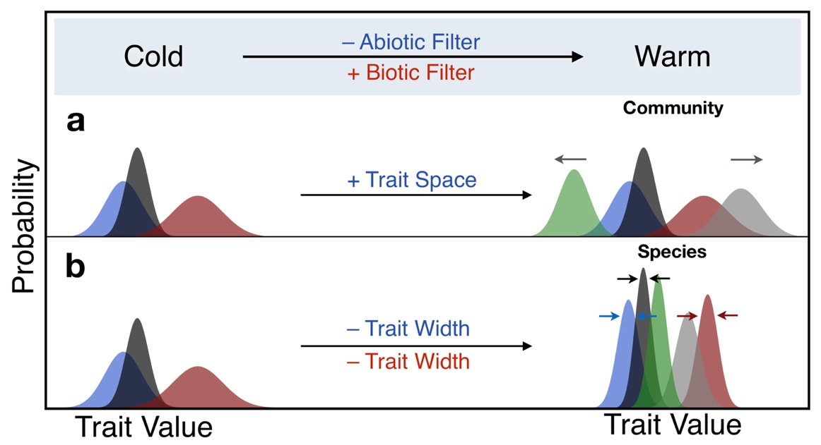
Figure 4. A schematic illustration of how niches and species diversity change with temperature. Each species has a trait distribution represented by a different color, and trait values are proxies for niche dimension values. In the heading, we show how a change in temperature causes changes in abiotic and biotic filters that affect trait dimensions in a and b. Panel a shows the effect on total trait space occupied by all species in the entire community, panel b shows the effect on trait width of individual species. A (–) indicates the filter strength or trait dimension is decreasing from cold to warm habitats, a (+) indicates an increase from cold to warm. The color of the text along arrows in the header and panels indicates corresponding cause and effect relationships: abiotic filters affect individual trait widths and community trait space (blue), biotic filters affect individual trait widths (red). Adapted from Read et al. 2018.

STUDENT INSTRUCTIONS

Building a General Model of Niches and Community Filters

In an extreme desert, there is strong selection to reduce water requirements to survive. In the tundra, there is strong selection pressure to tolerate freezing temperatures. But in the warm, wet tropics, selection to tolerate extreme environmental stressors is not as strong. So what traits are selected for in a tropical rainforest? Could any tree species survive in the Amazon?

In this section, we try to develop a general paradigm for when biotic (living) or abiotic (non-living) pressures are more important and how this should affect niche partitioning. We introduce a term that many community ecologists use when thinking about how organisms assemble in a community: filters. Filters prevent some traits from occurring, while others are allowed in. Let’s return to our example of the blue spruce. Blue spruce experience very cold winters with abundant snow, but many people plant them in much warmer, lowland habitats. Not only do blue spruce survive, they often grow faster in milder conditions. What’s going on? It appears that warm temperature is not a strong filter for blue spruce, but perhaps competition with lowland trees is. In this case, a biotic filter is limiting the lowland distribution of blue spruce. This biotic filter causes the realized niche of a blue spruce to be much narrower than its fundamental niche. Conversely, freezing conditions filter out many lowland species from moving into areas where blue spruce live.

Resources and conditions nearer the equator tend to be more stable, so a population that is successful at exploiting a particular resource may have a competitive advantage. Specialization can evolve in response to competitive pressures. A good example of trait and niche specialization occurs in the Galapagos Islands, among species known as ‘Darwin’s finches’ (Grant and Grant 2006). In the 1970s, the medium ground finch had members with both small and large beaks, which were better at handling and eating small and large seeds, respectively. However, the arrival of the large ground finch, which prefers large seeds, led to selection against large beaked members of the medium ground finch, reducing their frequency and competition between the two species. Thus, biotic filters, such as competition, can promote specialization of traits that limit interspecific competition. If competition is stronger in the tropics, we would expect less variation in traits within a species.

Overall, we might expect the strength of biotic and abiotic filters to vary in different conditions. More extreme environments will have stronger abiotic filters, but weaker biotic filters and vice versa. We can use this idea of filters to make predictions of niche similarity and niche partitioning in a landscape, and how this could affect species diversity in warm tropical latitudes or cold temperate latitudes.

To consider these questions, look at Figure 4, reading the captions and axis labels carefully. Answer the first step on your own, and then compare with a partner, proceeding through all steps. Be prepared to share your answers with the class.

Step One: Look at the uppermost panel layer. What does the ‘– Abiotic Filter’ and ‘+ Biotic Filter’ refer to? What do the plus and minus signs signify? Why should trait distributions change in that direction in warmer habitats? What does the red and blue text signify?

Step Two: Consider the panel with a change in trait space in 4-a. What is trait space? To answer this question, imagine the variety of plant forms and sizes in a tropical rainforest versus an arctic tundra, and consider all the life that may depend on those plants. Which has more variety? Which has more overall trait variety and niche space?

What do the arrows indicate? Why are there new colored distributions on the right? What are the implication for patterns of diversity?

Step Three: Consider panel b, in which niche width is changing. What is the effect of hypothesized niche width shifts on overlap? How does it affect competition? What do the new colored distributions represent? What are the implications for local diversity and the latitudinal diversity gradient?

Step Four: Figures without data are called schematics. Why do scientists publish schematics? What purpose do schematics serve?

Post-class Assignment: Please complete the following question for homework.

1. Imagine walking into a tropical rainforest or a desert and noting common plant forms you would expect to see. With this in mind, draw a schematic similar to what you have seen in Fig 4a, but with precipitation as the main environmental variable, mature height as the trait value (i.e., when plants stop growing taller), high rainfall is on the left, and low rainfall is on the right. Draw the expected changes in distributions and label each distribution as a plant type, including: a shrub, a small tree, a large tree, a vine, a palm, a bromeliad, and moss. Add the – and + signs where they are appropriate. Note which environment has more varieties of plants in the schematic.

NOTES TO FACULTY

Here students will apply critical thinking skills and previously discussed ideas to see how scientific concepts and ideas can be communicated with schematic figures. Students can use think-pair-share to analyze the questions, and the instructor can circulate after a few minutes to learn which concepts are challenging and may deserve general discussion.

Below we provide answers to the in-class questions and post-class assessment.

Step One: Look at the uppermost panel layer. What does the ‘– Abiotic Filter’ and ‘+ Biotic Filter’ refer to? What do the plus and minus signs signify? Why should trait distributions change in that direction in warmer habitats? What does the red and blue text signify?

The negative sign indicates a negative relationship: as x increases, y decreases. In this case, as temperature increases, abiotic filters are predicted to decline in strength. The plus sign indicates a positive relationship: as x increases y increases; equivalently, as x decreases y decreases. As temperature increases, biotic filters are expected to increase in importance.

The color of text in each panel helps links cause with effect. As biotic filters (cause; red) increase in warmer environments, species niche widths (effect; red) are predicted to decline to reduce competition. As abiotic filters decline in warm habitats (cause; blue), community niche space (effect; blue) is predicted to increase, while species niche widths (effect; blue) decline.

Step Two: Consider the panel with a change in trait space in 4-a. What is trait space? To answer this question, imagine the variety of plant forms and sizes in a tropical rainforest versus an arctic tundra, and consider all the life that may depend on those plants. Which has more variety? Which has more overall trait variety and niche space?

Trait space is the range of a trait (in the case of one trait), or the total variety of traits (for multiple traits). In Fig 4b, the total trait range or variety increases in warm habitats. This is because environments get more stable and favorable for life in warmer areas, permitting a greater variety of niches and body plans. For instance, tropical rainforests have a wider variety of plant forms (e.g., palms, vines, epiphytes, tree ferns, moss) or animals (e.g., insectivores, frugivores, nectivores, carnivores, omnivores) than temperate rainforests. The appearance of new colors represents additional species that have new trait values. Overall, greater niche space permits greater trait, niche, and species diversity.

Step Three: Consider panel b, in which niche width is changing. What is the effect of hypothesized niche width shifts on overlap? How does it affect competition? What do the new colored distributions represent? What are the implications for local diversity and the latitudinal diversity gradient?

As species become more specialized, their niche widths contract. For instance, their diet breadth might become narrower. This specialization permits more opportunities for other species to coexist without directly competing and decreasing niche overlap. Overall, narrower species trait widths can support greater overall diversity. Environments with more niche space and narrower niche widths should be able to support more species. Thus, the tropics should hold more diversity if our niche diagram, or schematic, is correct.

Step Four: Figures without data are called schematics. Why do scientists publish schematics? What purpose do schematics serve?

Schematics are visual display of ideas that are often more intuitive than verbal descriptions. Watson and Crick built cardboard models of the double helix DNA molecule when they were first trying to figure out its structure to recreate Rosalind Franklin’s x-ray images of DNA –in essence, a 3D schematic. Their publication in the journal Nature included a schematic of the corkscrew-shaped molecule of genetic inheritance. In ecology, a famous drawing of an island biogeography schema of diversity intuitively captures how island diversity represents the balance of mainland emigration and local extinction. Schematics can communicate the general shape of predictions and mathematical relationships without complex equations, and they are frequently more specific and clear than a lengthy verbal description. Even theorists trying to understand an idea on their own may draw out a schematic to puzzle over. Despite their training in mathematics and statistics, scientists – like non-scientists – often understand and communicate ideas more easily with pictures.

Schematics can also help scientists think about ways to test and plot their results. The common currency of science is peer-reviewed publications, and the core findings of any scientific paper are typically summarized in a few figures. Schematics not only illustrate scientific predictions, but they can guide the presentation of real data and help evaluate empirical findings.

Post-class assignment. Imagine walking into a tropical rainforest or a desert and noting common plant forms you would expect to see. With this in mind, draw a schematic similar to what you have seen in Fig 4a, but with precipitation as the main environmental variable, mature height as the trait value (i.e., when plants stop growing taller), high rainfall is on the left, and low rainfall is on the right. Draw the expected changes in distributions and label each distribution as a plant type, including: a shrub, a small tree, a large tree, a vine, a palm, a bromeliad, and moss. Add the – and + signs where they are appropriate. Note which environment has more varieties of plants in the schematic.

Overall, the total niche space (panel a; i.e., the total variety of plant sizes and the non-plant life it supports), would decline in a desert as forms such as vines, bromeliads and tall trees disappear, and mosses become less common. To encourage critical thinking, rather than rote copying, we ask the students to reverse the pattern, with favorable rainforest conditions on the left and harsh arid conditions on the right. New species/forms, such as epiphytes, will appear on the left, and arrows can move right to left with the same sign as Fig. 4, or left to right with opposite signs.

RESOURCES
- An introduction to histograms and frequency distributions:
  - Plotting and understanding histograms
    - https://www.khanacademy.org/math/probability/data-distributions-a1/displays-of-distributions/v/histograms-intro
  - Linking histograms to frequency distributions in excel
    - http://www.informit.com/articles/article.aspx?p=2201796&seqNum=4
- More on niches and diversity
  - How niche differences promote diversity:
    - ‘The Maintenance of species diversity’. J. Levine, 2010. Nature Education Knowledge.
      - https://www.nature.com/scitable/knowledge/library/the-maintenance-of-species-diversity-13240565
  - Niches, and why species live where they do:
    - ‘Environmental constraints to the geographic expansion of plant and animal species’. C. Mott, 2010. Nature Education Knowledge
      - https://www.nature.com/scitable/knowledge/library/environmental-constraints-to-the-geographic-expansion-of-13236052
  - Biogeography and spatial patterns of diversity:
    - ‘Effects of biogeography on community diversity.’ T. McGlynn. 2010. Nature Education Knowledge.
      - https://www.nature.com/scitable/knowledge/library/effects-of-biogeography-on-community-diversity-13260138
  - Niches vs neutral theories of species diversity:
    - ‘No need for niches? Neutral theory explains biodiversity when species are identical.’ W. Harpole, 2010. Nature Education Knowledge.
      - https://www.nature.com/scitable/knowledge/library/neutral-theory-of-species-diversity-13259703
- About the National Ecological Observatory Network
  - http://www.neonscience.org/

LITERATURE CITED
Adler, P. B., A. Fajardo, A. R. Kleinhesselink, and N. J. Kraft. 2013. Trait‐based tests of coexistence mechanisms. Ecology Letters 16:1294-1306.

Connell, J. H. 1961. The influence of interspecific competition and other factors on the distribution of the barnacle Chthamalus stellatus. Ecology 42:710-723.

Grant, P. R., B. R. Grant. 2006. Evolution of character displacement in Darwin’s Finches. Science 313:224-226.

Hubbell, S. P. 2001. The unified neutral theory of biodiversity and biogeography (MPB-32). Princeton University Press.

Hutchinson, G. 1957. Concluding remarks. Pages 415-427 in Cold Spring Harbor Symposium Quantitative Biology.

Jenkins, C. N., Van Houtan, K. S., Pimm, S. L. & Sexton, J. O. 2015. US protected lands mismatch biodiversity priorities. Proceedings of the National Academy of Sciences 112:5081-5086.

Kraft, N. J., R. Valencia, and D. D. Ackerly. 2008. Functional traits and niche-based tree community assembly in an Amazonian forest. Science 322:580-582.

Mittelbach, G. G. 2017. Ecology: A matter of time for tropical diversity. Nature 550:51-52.

MacArthur, R. H. 1972. Geographical Ecology: Patterns in the Distribution of Species. Princeton University Press.

Peters, R. H. 1983. The Ecological Implications of Body Size. Cambridge Univ. Press, Cambridge, MA.

Read, Q. R., J. M. Grady, P. L. Zarnetske, S. Record, B. Baiser, J. Belmaker, M. N. Tuanmu, A. Strecker, L. Beaudrot, and K. Thibault. 2018. Among-species overlap in rodent body size distributions predicts species richness along a temperature gradient. Ecography 41:1718–1727. doi: 10.1111/ecog.03641

Schemske, D. W., G. G. Mittelbach, H. V. Cornell, J. M. Sobel, and K. Roy. 2009. Is there a latitudinal gradient in the importance of biotic interactions? Annu. Rev. Ecol. Evol. Syst. 40:245-269.

Usinowicz, J., C.H. Chang-Yang, Y.Y. Chen, J.S. Clark, C. Fletcher, N.C. Garwood, Z. Hao, J. Johnstone, Y. Lin, M.R. Metz, T. Masaki, T. Nakashizuka, I.F. Sun, R. Valencia, Y. Wang, J.K. Zimmerman, A.R. Ives, and S.J. Wright. 2017. Temporal coexistence mechanisms contribute to the latitudinal gradient in forest diversity. Nature 550, 105–108.

Varshney, L. R. and J. Z. Sun. 2013. Why do we perceive logarithmically? Significance 10:28-31.

COPYRIGHT STATEMENT
The Ecological Society of America (ESA) holds the copyright for TIEE Volume 14, and the authors retain the copyright for the content of individual contributions (although some text, figures, and data sets may bear further copyright notice). No part of this publication may be reproduced, stored in a retrieval system, or transmitted, in any form or by any means, electronic, mechanical, photocopying, recording, or otherwise, without the prior written permission of the copyright owner. Use solely at one's own institution with no intent for profit is excluded from the preceding copyright restriction, unless otherwise noted. Proper credit to this publication must be included in your lecture or laboratory course materials (print, electronic, or other means of reproduction) for each use.
To reiterate, you are welcome to download some or all of the material posted at this site for your use in your course(s), which does not include commercial uses for profit. Also, please be aware of the legal restrictions on copyright use for published materials posted at this site. We have obtained permission to use all copyrighted materials, data, figures, tables, images, etc. posted at this site solely for the uses described at TIEE site.
GENERIC DISCLAIMER
Adult supervision is recommended when performing this lab activity. We also recommend that common sense and proper safety precautions be followed by all participants. No responsibility is implied or taken by the contributing author, the editors of this Volume, nor anyone associated with maintaining the TIEE web site, nor by their academic employers, nor by the Ecological Society of America for anyone who sustains injuries as a result of using the materials or ideas, or performing the procedures put forth at the TIEE web site, or in any printed materials that derive therefrom.

