**How do Lake Ecosystems Change with Increases in Dissolved Organic Matter (DOM) and Reduced Water Clarity?**

***Long-term investigations in lake ecology***

**Authors:**

Elizabeth Mette1, [dickmaem@miamioh.edu](mailto:dickmaem@miamioh.edu)

Erin Overholt1, [overhoep@miamioh.edu](mailto:overhoep@miamioh.edu)

Thuc Doan Nguyen1, [nguyend2@miamioh.edu](mailto:nguyend2@miamioh.edu)

Rachel Pilla1, [pillarm@miamioh.edu](mailto:pillarm@miamioh.edu)

Craig Williamson1, [willia85@miamioh.edu](mailto:willia85@miamioh.edu)

1Miami University, Department of Biology, Oxford, Ohio, USA

*This document was designed using the Navigation option in Microsoft Word, allowing the user to use an outline to navigate to selected parts of the document. To use this option, in Word under “View” check the box next to “Navigation Pane”. This will display an outline of the document through which the user can navigate to selected sections.*

Abstract:

Lakes worldwide have been undergoing “browning” as dissolved organic matter in aquatic systems has been increasing. This “browning” has implications for aquatic processes as increased dissolved organic matter has been shown to have effects on lake thermal structure, nutrient cycling, and dissolved oxygen levels, and is often accompanied by an increase in pH as surface waters recover from anthropogenic acidification as well. In this exercise, students will use an interactive web-based app to explore a 30+ year lake data set to investigate how lake “browning” is correlated with abiotic (light penetration, dissolved organic carbon, water transparency and temperature, and dissolved oxygen) and biotic components (zooplankton abundance and phytoplankton biomass) of aquatic systems. This app allows users to generate graphs to easily visualize data sets. Through this inquiry-based exercise, students will be guided to ask questions about and explore these data. This exercise, through its use of this app, is uniquely designed to enable the user to easily explore and understand an extensive long-term data set.

Learning Objectives:

* Gain insights into how increases in dissolved organic matter (DOM) and decreases in water clarity alter lake ecosystems. Students will explore data from 3 lakes that have been decreasing in water clarity. They will be able to identify measures of water clarity, as well as several abiotic and biotic components that changed as waters became less transparent.
* Explore how different types of lakes change with long-term changes in water clarity due to “browning” both with respect to biotic and abiotic components. Students will explore data from 3 lakes that vary in their productivity and water clarity, allowing them to observe how lake ecology can differ both over time and among systems. They will be able to discuss ways in which water quality (DOC, temperature, dissolved oxygen) differed and changed among these lakes, as well as ways in which the biota (zooplankton communities and phytoplankton biomass) changed over time.
* Gain insights into lake ecology by exploring a real-world data set, answering scientific questions, and testing hypotheses related to three types of small temperate lakes. Through this exercise students will learn how scientific observations lead to questions, and will gain experience asking and answering those questions using an actual scientific data set. They will be able to use data to answer questions and make observations about an ecological system, and also gain important insights into the differences between correlation and causation.
* Students will use time series plots of lake data to understand changes in and between lakes over time. Through the exploration of these real-world data sets students will gain data and graph interpretation skills.

Timeframe:

The material presented here can fit nicely in a normal 2-4 hour lab, or can be extended for even a semester-long independent project. Some or all questions can be utilized dependent on time availability and level of the students or course. The instructor portion of this exercise guides the instructor through selecting which questions to use in this exercise.

List of Materials:

This exercise requires access to a computer with internet access, as it utilizes a web-based [app](https://dataviz.miamioh.edu/PennsylvaniaLakes/).

The supplemental class demonstration requires the following:

* 3 glass jars, such as beakers
* 2 black tea bags
* Boiling water (750 mL)
* DOM demonstration template (can be printed from this document)

***Suggested Introductory Reading (See references for other suggested readings):***

Williamson CE 2020. Lake management in a browning world: Beyond the holy grail of nutrients. LakeLine Spring 2020: 6-10. <https://www.nalms.org/product/lakeline-40-1-lake-browning/>

Approach and Context:

*In this inquiry-based lesson, students will use an accessible, real-world data set on three small temperate lakes of differing trophic status to explore changes in the structure and function of lake ecosystems as dissolved organic matter increases, causing “browning”.*

Perhaps one of the most useful paradigms for assessing water quality in lakes has been the strong relationship between total phosphorus and chlorophyll (Figure 1). Phosphorus is a key nutrient, along with nitrogen, that limits algal productivity, and in excess can contribute to harmful algal blooms. Thus, nutrient availability is a useful mechanism to understand, predict, and control algal blooms in lakes. Yet we need to expand this “holy grail of limnology” (Williamson et al. 1999, Williamson 2020). Photosynthetic organisms need not only nutrients, but light (and water, which is always available in aquatic ecosystems); and algae can be light-limited, especially in browner lakes. Water transparency, and thus light availability, has been changing substantially in lake ecosystems in recent decades as many lakes are turning browner, while in other lakes invasive mussel species are increasing water transparency. For example, some of the Laurentian Great Lakes are experiencing up to a doubling of their transparency related to invasions of Quagga and Zebra Mussels (Bunnell et al. *in press*). Water transparency is regulated by particulate matter suspended in the water column (algae and suspended sediments), and dissolved material that influences water color (dissolved organic matter).

Despite management measures that have reduced nutrient inputs to lakes, total phosphorus and chlorophyll have not shown major changes in recent decades across over a thousand lakes in Central and Northeastern USA (Figure 2). But water transparency has been changing. In particular, dissolved organic matter (DOM) has been increasing in many lakes in recent years, which decreases water transparency and thus light availability in the water column (Figure 3) (Williamson and Neale, *in preparation)*. This increase in DOM (measured as DOC - dissolved organic carbon) causes a phenomenon known as “browning”, because increases in DOM result in browner-colored water. This browning is impacting the light environment of lakes, reducing light transmission through the water column. As light is essential for many key ecological processes, from photosynthesis to feeding by fish, this has important implications for lake ecosystems.

In this inquiry-based exercise, students will explore how browning changes the light environment and alters lake ecosystems. This exercise employs real-world lake data sets from 3 lakes that have been undergoing browning in northeastern North America. Long-term data are available for these lakes since 1988, and high frequency data since 2017. This long-term data set is [freely available](https://portal.edirepository.org/nis/mapbrowse?scope=edi&identifier=186) through the Ecological Data Initiative’s (EDI) data repository. Through a series of teacher-provided and student-derived questions, students will explore this lake data set. They will use a web-based app which allows the user to instantly generate graphs of user-selected portions of the data sets to explore these questions. Using a real-world data set, students will gain an understanding of how researchers use data to answer questions and test scientific hypotheses, while themselves learning more about the central role of DOM and light in lake ecology, extending the traditional chlorophyll-nutrient paradigm.

For further discussion of the issues and concepts addressed in this exercise in a highly accessible format, see [Williamson CE 2020. Lake management in a browning world: Beyond the holy grail of nutrients. LakeLine: 6-10](https://z0ku333mvy924cayk1kta4r1-wpengine.netdna-ssl.com/wp-content/uploads/2020/04/40-1-3.pdf).

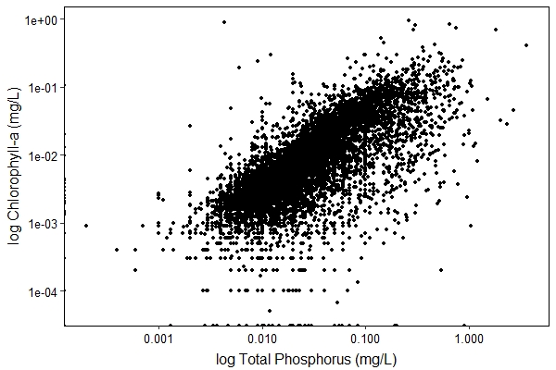

Figure 1: Traditionally, lake productivity has been considered in relation to nutrient levels. As nutrient availability (especially phosphorus) increases, so does primary production. In the above figure, using data points from over 4000 global lakes, we can see a positive correlation between total phosphorus (TP) and chl-a (chlorophyll-a, an indicator of primary productivity). *Data for this figure were obtained from Fillazola et al. 2020;* [*https://doi.org/10.1038/s41597-020-00648-2*](https://doi.org/10.1038/s41597-020-00648-2)*.*

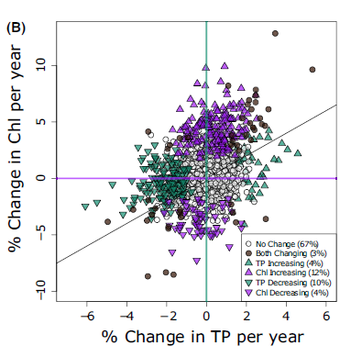

Figure 2: In a survey of 1435 lakes in the northeastern United States from 1991-2013, in the majority of lakes (67%) no change (gray circles) was found in chlorophyll (Chl) or total phosphorus (TP). *From Figure 3b in Oliver et al. 2017;* [*https://doi.org/10.1111/gcb.13810*](https://doi.org/10.1111/gcb.13810)*.*

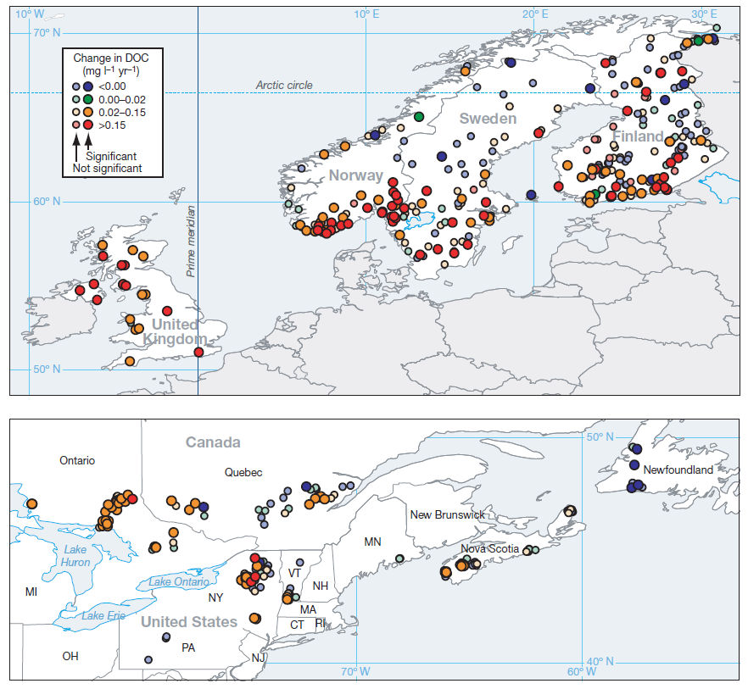

Figure 3: A survey of lakes across Northeastern North America and Northern Europe (1990-2004) showed widespread browning (increases in DOC) in lakes. *From Figure 1 in Monteith DT et al. 2007;* [*https://doi.org/10.1038/nature06316*](https://doi.org/10.1038/nature06316).

Ecological Background:

Traditionally, lakes have been classified across a productivity gradient as oligotrophic, mesotrophic, or eutrophic (low to high primary productivity). Lakes are assigned these designations based on key nutrients that limit phytoplankton growth, with higher nutrient availability (primarily nitrogen and phosphorus) resulting in higher productivity. While nutrients are undeniably a strong regulator of lake productivity (Figure 1), nutrients alone do not describe all of the variation in productivity across lake systems (note substantial scatter in Figure 1). Sunlight is also an essential resource for photosynthesis, and its availability can have strong impacts on productivity. In many natural lakes, dissolved organic matter (DOM) can be one of the most important regulators of the amount of underwater light. DOM is largely terrestrially-derived from organic matter resulting from incomplete decomposition in the lakes’ watersheds (Figure 4). Lakes high in DOM are brown in color and classified as dystrophic, and those high in both DOM and chlorophyll are murky in color and classified as mixotrophic. Mixotrophic lakes are becoming more prevalent in the past decade in the United States, with an associated decrease in clear, “blue” lakes (Leech et al. 2018) (Figure 5). Because DOM absorbs light, it reduces light penetration through the water column, with less PAR (photosynthetically active radiation) and UV radiation penetrating into deeper waters. PAR is a significant component of incident light, making up 45% of solar radiation that reaches the earth, and comprises the same wavelengths as visible light (400-700 nm). This has implications for a wide range of lake processes, including thermal structure, dissolved oxygen, and nutrient cycling (Williamson et al. 2015) (Figure 6).

a. b.  c. 

Figure 4: DOM (dissolved organic matter) is leached into the water by partially decomposed organic substances. Examples of this abound. (a) The color of tea and coffee comes from dissolved organic matter leached from tea leaves and coffee grounds. (b) Likewise, following a rainfall, leaf-shaped stains are often visible on the sidewalk, as organic matter is leached from fallen leaves. (c) The coloration of water by terrestrially-derived organic material results in a yellow to brownish-black coloration, with the degree of coloration dependent on the source of the organic material from which the DOM is leached.



Figure 5: Lakes can be classified as blue (clear water, low productivity), green (high chlorophyll and productivity), brown (high dissolved organic matter), or murky (high dissolved organic matter and chlorophyll, or mixotrophic). Approximately 1000 US lakes were surveyed in 2007 and 2012 and classified as blue, green, brown, or murky. The relative change in abundance of lakes in each category is plotted above. Error bars represent 95% confidence intervals. *From Figure 1 in Leech et al. 2018;* [*https://doi.org/10.1002/lno.10967*](https://doi.org/10.1002/lno.10967)*.*

1. 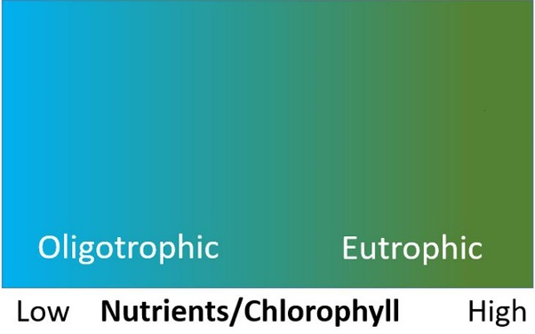 b. 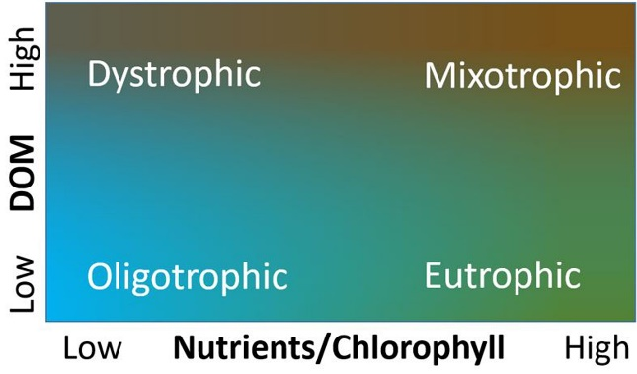

Figure 6: (a) Traditionally, the productivity of lakes has been considered in relation to nutrient levels in the lake, with increasing nutrients (phosphorus and nitrogen) leading to more productive (greener) waters. (b) DOM (dissolved organic matter) is also an important factor to consider in the productivity of lakes. Browning of the water in lakes by inputs of DOM turns water brown, reducing water transparency. DOM can thus be considered as a second critical dimension when characterizing lakes, as the transparency of lakes with both high nutrient levels and high DOM inputs decreases due to both the green coloration from chlorophyll and brown DOM.

In brown lakes (as compared to clearer lakes), light is attenuated more quickly in the upper waters, leading to stronger vertical gradients in temperature, oxygen, and light in the water column. Stronger thermal gradients result in more pronounced density gradients, and waters that are less easily mixed vertically. Mixing of the waters in the lake allows nutrients and other resources to be redistributed more uniformly in the vertical water column. With decreased light penetration, the compensation depth, measured as the depth where PAR is 1% of surface values, decreases. Above the compensation depth, photosynthesis (oxygen production) is greater than respiration (oxygen consumption), and below this depth respiration is greater than photosynthesis. When this depth becomes shallower in the water column the chance of hypoxia (low dissolved oxygen) and anoxia (no dissolved oxygen) developing in the deep waters increases, as more oxygen is consumed than is produced, depleting the oxygen in deeper waters. Stronger thermal gradients exacerbate this risk because with less frequent mixing of the water column there is a greater chance that oxygen in the deep water will be completely consumed before highly oxygenated water from the upper waters can replenish it. Anoxia in the deep waters has implications for nutrient levels in the lake, as previously unavailable phosphorus that was bound up in the lake sediments can be released into the water column under anoxic conditions. When the waters of the lake then mix vertically during seasonal periods of lake turnover (spring and fall in temperate lakes), this phosphorus from the deep waters of the lake is introduced throughout the water column, promoting increases in primary productivity. This in turn further exacerbates the above effects through a positive feedback wherein increased primary productivity also reduces light availability in the lake (Knoll et al. 2018).

These changes to the lake have implications for the lake’s biota. High DOM contributes to warming of the upper waters of the lake, as the darker waters absorb more sunlight. Warm waters favor cyanobacteria in the phytoplankton community, some of which produce toxins, including neuro- and hepatotoxins that can be hazardous to human health. Decreased light penetration also affects the zooplankton and fish communities in the lake, as reduction in light affects visual predators, and reduction in penetration of both UV radiation and visible light impacts the vertical distribution of species. Organisms that previously retreated to deeper waters to avoid UV light exposure or predation are able to inhabit shallower layers of the lake as high DOM levels selectively reduce the penetration of UV relative to visible light in the water column.

Over the past decades DOM inputs to lakes have been increasing (Monteith et al. 2007, DeWit et al. 2016, Strock et al. 2017). With greater overall precipitation and stronger precipitation events with climate change, we see higher flushing of DOM from the watershed into lakes. Likewise, as soils are recovering and becoming more basic with the success of acid rain control measures over the past decades, DOM has become more easily mobilized to downstream waters. This browning of lakes is expected to continue as climate change continues to drive stronger precipitation events. Increased precipitation creates ideal conditions for anoxic soils that generate more DOM, as well as increased runoff that flushes DOM into downstream water bodies. With this continued browning of our lake systems, the impact of light limitation is an important factor to consider in lake productivity.

The Lakes:

Since the late 1980s we have compiled an extensive data set on three lakes in the Pocono Mountains region of Pennsylvania, in northeastern USA (Figure 7). This data set consists of regular limnological measurements throughout each annual growing season, as well as high temporal frequency data from more recent years which allow for an in-depth look at lake processes. These lakes represent a range of productivity and water transparency, with an oligotrophic (blue) lake (Giles), an oligo-mesotrophic (brown) lake (Lacawac), and a eutrophic (green) lake (Waynewood). Lacawac and Waynewood are of similar size with lake areas of 21.4 and 28 ha, and maximum depths 13 and 12.5 m, respectively. Lake Giles is about twice as large as the other two lakes (48.1 ha lake area and 24.1 m maximum depth). With increased precipitation events and decreased soil acidification over the three decades during which data have been collected on these lakes, their waters have been experiencing browning with increased inputs of DOM. This data set characterizes these lakes using a suite of physical, chemical, biological, and optical measurements, with its unique focus on the optical characteristics of the lakes, setting it apart from other long-term and high-frequency limnological data sets.

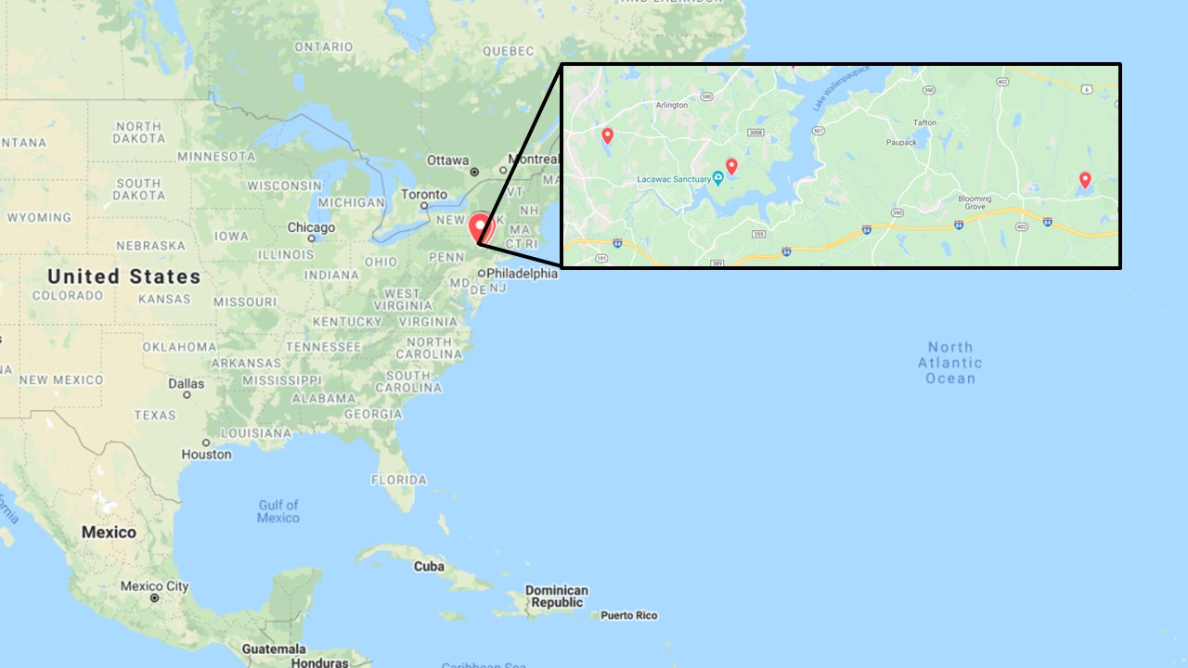

Figure 7: The study lakes (Lacawac, Giles, and Waynewood) are located in the Pocono Mountains region of northeastern USA (Pennsylvania). *An interactive Google map of the locations can be accessed via* [*https://www.google.com/maps/d/edit?mid=1molH3D8yfBLKKFNe0fg-Qa-S6-hEatFX&usp=sharing*](https://www.google.com/maps/d/edit?mid=1molH3D8yfBLKKFNe0fg-Qa-S6-hEatFX&usp=sharing)*.*

Procedure and General Instructions (Instructor):

In the following sections the instructor notes, elaboration on topics, and sample plots generated by the app are shown (which are not presented in the student version). These parts are presented in blue font, and are not as much intended to give direct answers to the questions, as to provide elaboration and direction on topics which you might want to discuss with your students as they work through the exercise. Text in black font is identical to that supplied to the students in the following “Student” section. Key words are presented in ***bolded italics*** the first time they are presented in this section, and these key words and concepts are hyperlinked to and defined in the glossary at the end of this document. For an optional, simple class demonstration of the importance of DOM in changing the color of water, see the end of this document.

**Student Exercise:**

*In the following exercise users will explore real lake data using the web-based app, “Long-Term Changes in the Pocono Lakes”* [*(hyperlink to app)*](https://dataviz.miamioh.edu/PennsylvaniaLakes/) *to answer questions about how lakes are affected by changes in water transparency. Detailed instructions on using the app are available in the “Instructions_PoconoLakesApp” document included with this exercise.*

*Before beginning this exercise, explore the pages of the app to become familiar with the data available. Also, review the “**Approach and Context**”, “**Ecological Background**”, and “**The Lakes**” sections above, as they provide limnological and lake-specific information that will be important as you work through this section.*

This exercise is designed so that you can assign any or all parts of it to your students, depending on the needs and abilities of your class. The following questions are grouped into 3 sections below (A-C). Depending on the complexity you wish for this exercise, and the amount of time you want it to take, you can choose to have students complete any or all of these sections. Section A explores the causes of the changing light environments in these lakes. This question is recommended for all students, from high school to advanced (graduate) level. For beginning students (high school, beginning undergraduate) and / or shorter time allotments, you might choose to stop after section A. Sections B and C explore the effects of the changing light environment on the abiotic and biotic components of the lake ecosystem, respectively. They are intended for college and graduate-level students, as they encourage greater exploration of the data set. Several questions are posed within each of these sections (numbered 1, 2, 3, etc.). Depending on time and student ability, one or both of these sections can be assigned, as can some or all of the questions within a section. Following these exercises is an “Extension” section, intended for advanced students. In this section, students are asked to download data from this data set and explore it further on their own, outside of the app.

For this exercise, you will have access to 30 years of data from three lakes, Lacawac, Giles, and Waynewood (northeastern USA), which represent a range of productivity and water transparency. Giles’s water is of low productivity and relatively transparent, while Lacawac and Waynewood are moderate and more highly productive, respectively, and have much lower water transparency. Water transparency is controlled by particulates such as algae and suspended sediments, and ***dissolved organic matter*** in the water. Here we are going to focus on ways in which dissolved organic matter affects lakes, as particulates tend to be unimportant in controlling transparency in these and many other lakes fed more by seepage than by inlet streams or rivers. Water enters a lake either/ and from above ground sources such as inflowing streams and rivers, or below ground sources such as seepage of water from the ground. Lakes fed mainly by above ground sources are likely to have more inputs of particulates such as suspended sediments, which can influence their water clarity. Lakes such as the ones on which we will be focusing in this exercise are fed mainly by below ground sources through seepage, often through organic-rich soils, and their water clarity is likely to be more affected by dissolved organic matter.

DOM is changing in lakes on a global scale, contributing to lake “***browning***”. Consider how the corresponding reductions in water clarity might alter lake ecosystems. Using the data set available through [this app](https://dataviz.miamioh.edu/PennsylvaniaLakes/), explore how changes in transparency have altered the lake ecosystems of Lacawac, Giles, and Waynewood. The following questions are divided into 3 main topics (A-C), with several questions under each topic, all of which can be answered using the lake data set in this app. For each question, describe (in a few sentences) what you see as you plot the data using the app. Key words are ***bolded and italicized*** and linked to their definitions in the glossary.

*Correlation vs. Causation*: Limnologists, ecologists, and other scientists use many approaches to investigate how natural systems work. Experimental approaches manipulate a single variable or set of variables and have a “control” treatment where all other variables are kept constant. This approach enables a scientist to clearly identify causation, and mechanism – what is actually causing an observed change in the response variable. An alternative method that is used in this exercise is to use long-term data to identify how changes in driver variables (e.g. water clarity) correlate with trends in response variables (e.g. temperature and oxygen) over longer periods of time. One important caveat here is that correlation is not causation. For example, at the same time that water clarity is changing due to increases in DOM in these lakes, there could be some alternative explanation for the observed changes in the response variables. During this exercise, you are asked to carefully consider what other changes might occur in lakes that could contribute to the changes in response variables that you are investigating. Think about mechanisms that might drive these changes, and the likelihood of these other variables being important. For example, during browning, there is often a strong increase in pH, and there may be changes in other inputs such as salts from roads that may alter both abiotic and biotic variables in lakes. Cautious and conservative interpretation of long-term data and understanding this critical difference between correlation and causation is a core learning objective in this exercise.

Throughout this exercise students will use the “Long-Term Changes in the Pocono Lakes” app to explore a long-term data set. As they begin this exercise, have them open this app, which is available online at <https://dataviz.miamioh.edu/PennsylvaniaLakes/>. Encourage students to use sample plots to support their answers, using screenshots of some plots generated by the app. Remind students that the plots generated by the app show trend lines among the data points, with significant trends illustrated with a solid line. Here you might want to briefly discuss statistics with your students. The plots displayed by the data app are time series plots, in which significant (solid trend line, p<0.05)) and non-significant (dashed trend line, p>0.05) trends in a selected variable are plotted over time. Significance is determined using a Mann-Kendall nonparametric trend test, and results of the statistical test are displayed below the plot in the app. For further discussion of a Mann-Kendall test, see Gocic and Trajkovic (2013). Here would also be an appropriate time to discuss correlation vs. causation with your students. Specifically, in this exercise they will be looking at trends in the data over time. Trends among variables does not guarantee that one caused the other, but trends suggest that they may be related. The use of statistics in analyzing these trends among variables would be required to more definitively say whether one caused the other, but that is outside the scope of this exercise. Rather in this activity the main objective is to give students experience beginning to explore trends in a complex data set using graphs to visualize the data.

Be sure to note here to your students that the plots displayed by the app do not all use the same scale, but rather optimize the data display. Thus, as they compare plots it is important to consider the significance of trends shown by the trend line. Likewise, when comparing the values among multiple plots note the y-axis scale, as the plots won’t all necessarily be displayed on the same scale. As an example, in the app you can show your students the epilimnion chlorophyll data for each lake. Note how the y-axis scale varies greatly between lakes, with maximum values in the 30s for Waynewood, and in the single digits for Lacawac and Giles. This difference in scale is worth noting when comparing the lakes, and when observing trends in the data. If you look at these chlorophyll trends in Giles you will observe that the data do appear to increase slightly over time. However, this trend is not significant (as noted by the dashed trendline). Note that the fine scale on the y-axis of this plot (0-1.5) makes this trend appear more pronounced. If these data were observed on a courser scale (ie: 0-10) this slight trend would not be as apparent.

Throughout this (instructor) section, sample plots are provided to illustrate the trends that your students should observe in the app. Descriptions of the data in the plots and points to discuss with your students specific to each question are provided in blue font to help you guide your class through this exercise. *Note that it is possible that students may generate plots with the app that appear slightly different from the examples here. Specifically, theirs may contain later data points, due to the dynamic nature of this data set. The data set used in this app is updated regularly to include the most up to date data from these lakes.*

1. Consider how the light environment has changed in these lakes.
   1. How has transparency changed over time in these lakes? The depth to which 1% of subsurface light penetrates is often referred to as the ***1% attenuation depth***, and is a good indicator of water transparency for each of the various wavelengths of light. Conveniently, the 1% attenuation depth for ***PAR*** is the ***compensation******depth***. This is ecologically important because it is the depth below which respiration exceeds photosynthesis, and there is net oxygen consumption and the potential for ***hypoxia*** or ***anoxia*** (low, or no oxygen, respectively). Compare if and how the compensation depth (1% PAR depth) has changed over time in these lakes.

In the following plots note how transparency has decreased over time. The compensation depth has decreased over time and significantly so in Giles and Waynewood (as indicated by a solid trend line). Ask students to consider what might affect water transparency. The next question will explore some possible causes of changing transparency.

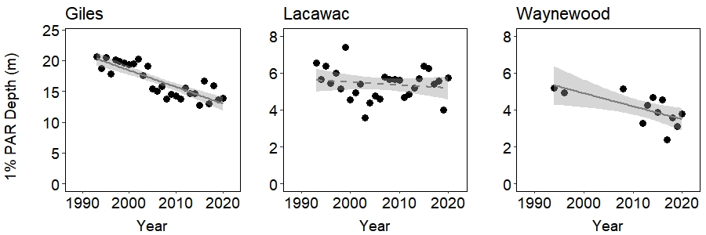

Sample Plot 1: The compensation depth is the depth at which PAR (photosynthetically active radiation) was 1% of subsurface light levels for each lake over time. Note difference in scale among lakes. Statistically significant trends are denoted with a solid trendline, and statistically non-significant trends with a dashed line.

* 1. As mentioned above, water transparency is influenced both by particulate and dissolved matter in the lake water. Use the data app to explore what you think may have contributed to these changes in transparency. Consider which variables in the data set might influence water transparency. Through the following two questions, explore how particulate (algae) and dissolved organic matter (measured as dissolved organic carbon, ***DOC***) have changed in each of these lakes.
     1. In this data set, chlorophyll measurements provide an estimate of algal biomass in the lake. How have chlorophyll levels changed over time in these lakes? Is chlorophyll a likely contributor to the observed changes in transparency?
     2. Dissolved organic matter results from incomplete decomposition of primarily terrestrially-derived organic material. It influences water color through lake browning. How have DOC concentrations changed over time in these lakes, and are they a likely contributor to observed changes in water transparency?

The following plots show chlorophyll and DOC trends over time in the epilimnion of all 3 lakes (note that y-axis scale differs between plots). Chlorophyll is an indicator of primary production levels. Ask students to consider how primary production compares among these lakes (which one is most/least productive—highest/ lowest chlorophyll levels). Discuss whether primary production has changed significantly over time in these lakes. Algal concentrations (measured as chlorophyll) are one form of particulate matter that could influence water transparency. As we saw transparency decrease over time in (some of) these lakes (Giles and Waynewood), we would expect to see a corresponding increase in something that influences transparency. Similarly, ask students if DOC has changed over time in these lakes, and how the changes might affect water transparency.

The following sections (B and C) will ask students to explore how this changing light environment affects various components of the lake ecosystem.

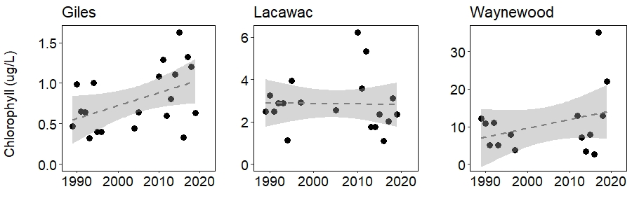

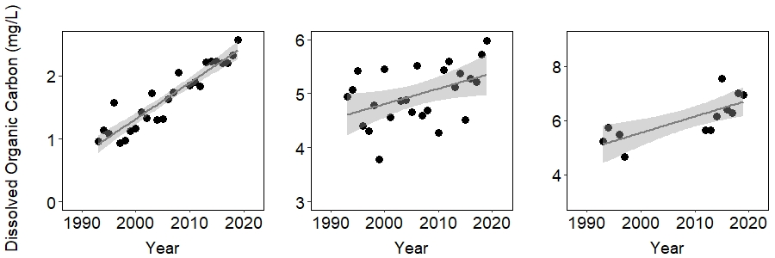

Sample Plot 2: Chlorophyll trends (top row) and DOC (dissolved organic carbon) (bottom row) were plotted over time for each lake. Each point represents a summer average value. Statistically significant trends are denoted with a solid trend line, and statistically non-significant trends with a dashed line.

1. Light influences many ecological processes in lakes. What do these long-term data tell us about how the changing light environment has affected these lake ecosystems? In the following questions you will explore the implications of changing water transparency for water temperature and dissolved oxygen levels.
   1. Has water temperature changed over time in these lakes? Consider the upper (epilimnion) and lower (hypolimnion) layers of the lake. How do you explain any observed changes?
   2. In this geographic region, over the time period from 1988 to 2014, ***there were no significant long-term trends in air temperature*** (Pilla et al. 2018). This suggests that changing air temperature during this period was not the primary driver of changes in water temperature. In lake(s) in which you see a significant change in water temperature, how might DOC be influencing these temperature changes over time? More specifically, would you expect surface and deep water temperatures to change in the same way, or opposite ways? Why is this?

Significant trends in temperature were observed in Giles (see plots below for epilimnion and hypolimnion). Note that temperature has increased in the epilimnion (surface) but decreased in the hypolimnion (deep waters) (note that y-axis scale differs between plots). Ask students to consider what might be causing these contrasting temperature changes.

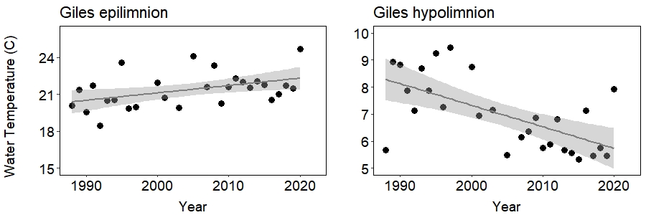

Sample Plot 3: Yearly average water temperature was measured in the lake’s epilimnion and hypolimnion. Statistically significant trends over time are denoted with a solid trend line.

As air temperature can’t be the driver of the observed changing water temperature in Giles (as noted in question B2, air temperature has not changed significantly, but water temperature has), consider how other factors have changed in this lake over time. In the previous set of questions, we explored changing water transparency and found that DOC has increased over this same time period, with the proportionally greatest increase in DOC found in Lake Giles. As DOC darkens the water, one could expect that that darker water might absorb more heat from sunlight, warming the surface waters (epilimnion). Over this same time period we saw a decrease in temperature of the deeper waters (hypolimnion), which might be explained by the decreased light penetration to these depths with increasing DOC. This increase in temperature difference between the upper and lower waters of the lake can influence lake dynamics, strengthening stratification and resulting in waters that aren’t as easily mixed. Temperate lakes such as these typically undergo temperature stratification where in the summer the lakes are stratified into 3 layers, an epilimnion (top layer of the lake) of warm water of uniform temperature, a metalimnion (middle layer of the lake) where temperature and oxygen levels decrease with depth (also called the “thermocline”), and a hypolimnion where temperature and oxygen levels are mostly uniform and low. (See “***lake stratification***” in the Glossary section for further description). In these lakes, the epilimnion typically extends from approximately 0-4m (Giles) or 0-3m (Lacawac and Waynewood), the metalimnion from 4-12m (Giles) or 3-5m (Lacawac and Waynewood), and the hypolimnion from the bottom of the metalimnion to lake bottom. These layers of the lake are not easily mixed because of their differences in temperature and water density. However, events such as wind, changing temperature, etc. can occasionally cause these waters to mix, and the closer in temperature (and thus density) the water is between the layers, the more easily mixing can occur. This mixing causes a redistribution of resources throughout the lake, as areas of higher concentrations of nutrients, phytoplankton, or zooplankton are mixed with those of lower concentrations. As the temperature difference between the upper epilimnion and lower hypolimnion waters has increased over the past decades, this vertical mixing of the lake waters has become less pronounced.

* 1. Oxygen is produced by primary producers (algae) during photosynthesis, and photosynthesis requires light. How would you predict that increasing DOC might influence oxygen levels? How have oxygen levels at shallow and deep depths changed over time, and are these changes related to changes in the light environment in these lakes?
     1. Using data in the “Abiotic” page of the app, explore if and/or how oxygen levels in the upper (epilimnion), middle (metalimnion), and lower (hypolimnion) layers of the lake have been affected. For this question, consider Lake Giles.

Significant trends over time were found in Lake Giles’s hypolimnetic dissolved oxygen levels, with hypolimnetic dissolved oxygen decreasing over time (Sample Plot 4).

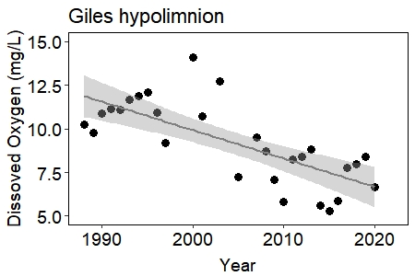

Sample Plot 4: Dissolved oxygen concentrations were measured in the hypolimnion of Lake Giles. Each point represents the annual summer average hypolimnetic dissolved oxygen. Statistically significant trends over time are denoted by a solid trend line.

Ask students to consider what might have contributed to these decreasing oxygen levels. What contributes to oxygen in lake water? Oxygen is consumed through respiration of organisms (bacteria during decomposition of DOC and other organic compounds, phytoplankton at low light levels, zooplankton, and fish) and produced through photosynthesis by primary producers (algae/phytoplankton and macrophytes). What measurement estimates the amount of primary producers in the open lake water? Chlorophyll has also shown a decrease over this same time period in the hypolimnion of Giles (Sample Plot 5). During this same time period, we have seen a decrease in light penetration through the water column, with a decrease in 1% PAR depth (Sample Plot 5). Consider that as light penetration to the deeper waters of the lake has decreased with decreasing clarity (and increased DOC), photosynthesis, which requires light, has also decreased (seen as decreasing chlorophyll), resulting in lower oxygen production in the deeper waters. Additionally, increased DOC in the water column results in a subsequent increase in DOC decomposition, a process which consumes oxygen. This, combined with an overall decrease in hypolimnetic oxygen production through photosynthesis would lead to an expected reduction in oxygen available in the hypolimnion.

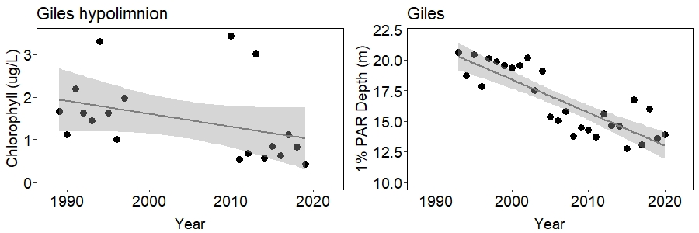

Sample Plot 5: Annual summer chlorophyll concentrations were measured in the hypolimnion of Lake Giles, and the average depth at which light reached 1% of subsurface levels was measured. Statistically significant trends are denoted with a solid trend line.

* + 1. Anoxia in the lower waters can cause phosphorus to be released from the sediments, reintroducing nutrients to the water column and fueling algal growth. Anoxic conditions become more likely towards the end of the summer, as oxygen may be used up and not replenished during the period of summer ***stratification***.
       - Have these lakes had significant drops in oxygen levels in the deeper waters of the lake? Use dissolved oxygen data on the “High-frequency” page to look at these patterns.

All 3 lakes experienced low oxygen to anoxic conditions in the late summer. See data around August in Sample Plot 6. These anoxic conditions have implications for the lake environment, as anoxic waters near the sediments have the potential to cause the release of phosphorus, a limiting nutrient, from the sediments. This phosphorus can then be mixed throughout the water column during fall turnover of the lake waters, increasing overall nutrients and thus primary production in the lake.

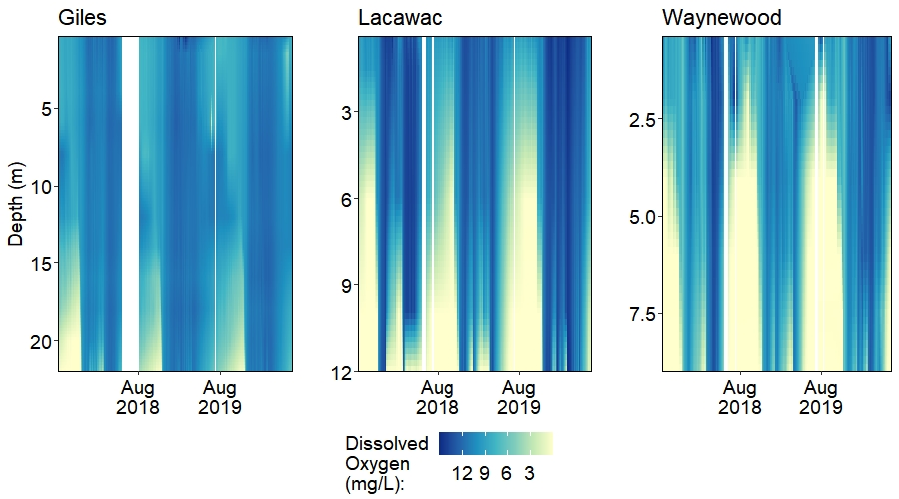

Sample Plot 6: Dissolved oxygen was measured throughout the water column continuously over time in Lakes Giles, Lacawac, and Waynewood. Higher oxygen levels are denoted by darker blue coloration, and low to no oxygen by white coloration.

* + - * How might increasing DOM increase the likelihood of anoxic conditions?

Ask students to consider how DOM affected light conditions in the lower waters. As light is essential for photosynthesis, decreased light would be expected to result in decreased photosynthesis, and thus decreased oxygen produced, leading to these low oxygen conditions. Additionally, the increase in organic matter from DOM fuels increases in respiration and oxygen consumption (through decomposition of this organic matter). Thus oxygen levels might be expected to decrease both due to decreased primary production and increased oxygen consumption.

1. In the previous questions we explored changes in the abiotic components of the lake due to changes in the light environment. Now consider impacts on the biotic communities.
   1. Light is essential for photosynthesis. In the open waters of these lakes (the pelagic zone), the predominant primary producers are phytoplankton (algae). Phytoplankton are found throughout the water column where light levels are high enough to support photosynthesis, typically where PAR is >= 1% of surface levels (1% PAR depth). Algal biomass is estimated through measurements of chlorophyll concentrations in lake water. In the following questions, you will consider how the changing light environment may have affected primary producers.
      1. Giles is a relatively clear lake. In the early 1990s, light (photosynthetically active radiation, PAR) penetrated to the bottom of the 22 m water column in levels high enough to support primary production (1% PAR depth). Revisit how Giles’s 1% PAR depths have changed over time (question 1). Has this affected primary production in the lower depths of Giles (hypolimnion)? How?

As shown by the 1% PAR depth in Sample Plot 7, the compensation depth has decreased from approximately 20 m in the early 1990s to approximately 13-15 m in recent years. In the early 1990s, light was sufficient for photosynthesis throughout most of the water column (as this lake is approximately 24 m deep). As the compensation depth decreased to approximately 15 m by 2020, the portion of the hypolimnion where light was sufficient for photosynthesis also decreased, which would lead one to expect primary production to also decrease over this time period in the hypolimnion. Considering chlorophyll as a proxy for primary production, ask students whether they think primary producers were affected by decreasing water transparency.

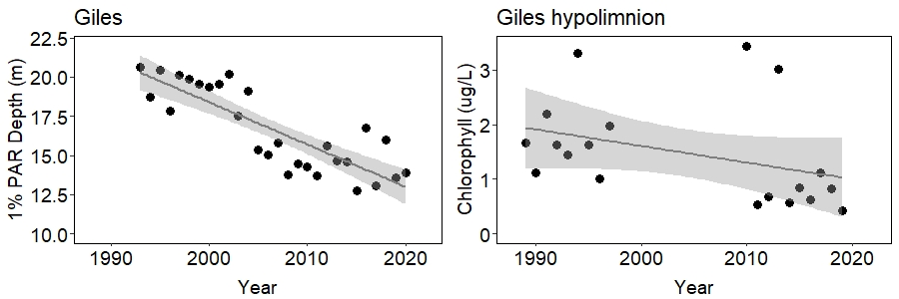

Sample Plot 7: Annual average depth at which PAR (photosynthetically active radiation) was 1% of subsurface levels, and summer average hypolimnetic chlorophyll concentrations in Lake Giles. Statistically significant trends are denoted by a solid trend line.

* 1. As light is made up of visible and UV wavelengths, it has effects on the biota in the lake, both through the damaging effects of UV on some organisms, and reduced visibility for others with decreases in visible light. While changes in UV and visible light directly affect some species, others are indirectly affected through predation and food supply. In the following questions you will consider how zooplankton communities have been affected as DOC levels have increased. As you answer these questions, consider the following pelagic food chains:

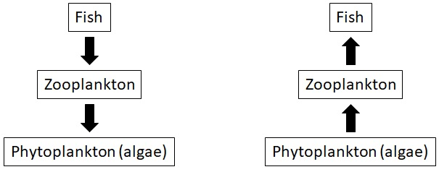

In both of these aquatic food chains, zooplankton are the critical intermediate link that can control both water quality (by grazing on bacteria and algae) and fish production (by providing food for smaller fish that are eaten by larger fish). The first shows the top-down effects of fish predation on zooplankton, and hence phytoplankton, while the second shows the bottom-up effects of food supply (phytoplankton) on zooplankton and fish. As you answer the following questions, consider whether phytoplankton (bottom-up) or fish (top-down) are more likely to be responsible for the changes you observe in the zooplankton communities.

These zooplankton communities are made up of the major zooplankton groups including rotifers, copepods, and cladocerans such as *Daphnia*. *Daphnia* and many copepods are generally larger in body size, and rotifers are smaller. *Daphnia* feed primarily by grazing on algae and bacteria, while copepods are more omnivorous, feeding on other small zooplankton including rotifers as well as larger algae. Rotifers most often graze on bacteria and algae, but some of the larger species are predatory and can feed on other rotifers. In the following questions you’ll be asked to consider how various groups of these zooplankton have changed over time and between lakes.

* + 1. Let’s look at zooplankton communities over the past 3 decades. Using data from Lake Giles, how have *Daphnia* populations changed?

Since the early 1990s, *Daphnia* abundance has decreased from approximately 6 organisms per liter to approximately 2 organisms per liter (Sample Plot 8). Ask students to consider what might be driving that decrease in *Daphnia* abundance. Consider the above food chain diagrams, which illustrate how *Daphnia* populations are impacted by top-down predation pressures and bottom-up food supply. An increase in predatory pressure (fish) and/or a decrease in food supply (phytoplankton) could drive this decrease in *Daphnia*. In the following parts of this question we’ll explore these possibilities.

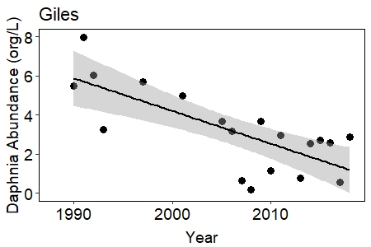

Sample Plot 8: Annual Daphnia abundance over time in Lake Giles. Statistically significant trends over time are denoted with a solid trend line.

* + 1. Refer to the above food chain diagrams. As *Daphnia* are grazers (consume phytoplankton) they can be affected by bottom-up effects of their phytoplankton food supply as well as top-down predation by fish. Over the past 3 decades there has been a marked increase in larval fish abundance, which is believed to have resulted from the combined effects of reduced UV light penetration with browning and increased pH with recovery from acid deposition. Revisit the chlorophyll data in the epilimnion of Lake Giles to explore how phytoplankton biomass has changed over the past 3 decades. Which biotic component (fish or phytoplankton) is more likely to be responsible for the observed changes in *Daphnia*? What role might changes in pH have played? Explain.

|  |  |  |
| --- | --- | --- |
| **Lake** | **CPUE 1990** | **CPUE 2014** |
| Giles | 0.0 | 5.5 |
| Lacawac | 1.6 | 5.0 |

Table 1: Catch per unit effort (CPUE) of juvenile planktivorous (young-of-year, YOY) fish was measured in 1990 and in 2014 in Lakes Giles and Lacawac. *From Williamson et al. 2015;* [*https://doi.org/10.1038/srep18666*](https://doi.org/10.1038/srep18666)*.*

Epilimnion chlorophyll (Sample Plot 9) has not shown a significantly increasing or decreasing trend over the past 30 years. As *Daphnia* populations have decreased, we would expect to see a corresponding decrease in their phytoplankton food if these trends were driven by bottom-up food supply pressures. Likewise, an increase in fish over this time period, as has been observed, would indicate an increase in predation pressure that could influence this decrease in *Daphnia*. These trends support stronger top-down predation effects on *Daphnia*. You might note too, that although not statistically significant at this point, chlorophyll trends toward increasing over time, which is consistent with a reduction in *Daphnia* grazers by fish. *Daphnia* are sensitive to acidic waters, but Lake Giles has become less acidic, with an increase in pH over time, so it is unlikely that recovery from acidification explains the decline in *Daphnia*.

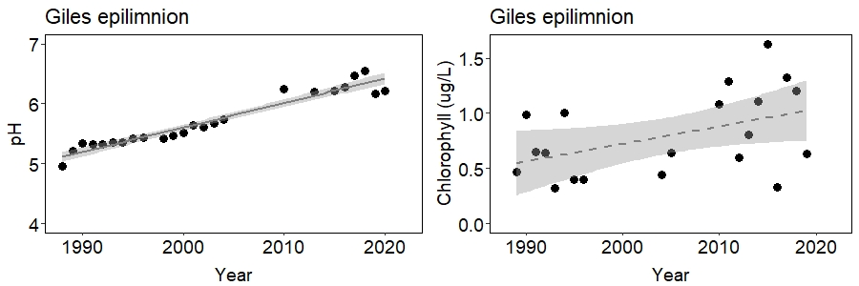

Sample Plot 9: Annual summer average pH levels and chlorophyll concentrations were measured in the epilimnion of Lake Giles. Statistically significant trends over time are denoted by the solid trend line, and non-significant trends by the dashed line.

* + 1. As DOC increases, visibility decreases, thus favoring predators that find their prey by touch (tactile predators) over those that rely on sight (visual predators). Some larger zooplankton (such as copepods) prey upon smaller zooplankton (rotifers). In these lakes, Cyclopoid copepods are common tactile predators that feed upon smaller rotifers such as *Gastropus*. Using Lacawac’s data, consider how water transparency has changed over the past 30 years. How has this affected the abundances of Cyclopoid copepods and their prey?

Over the past 30 years DOC (dissolved organic carbon) has been increasing in Lacawac. Increasing DOC contributes to browning of the water, reducing transparency. Secchi depth is a measure of water transparency. A black and white disk is lowered through the water column, and the depth at which it disappears from view is recorded as the Secchi depth. The decreasing Secchi depth over the past 3 decades is to be expected with decreasing water transparency (increasing DOC) (see below plots).

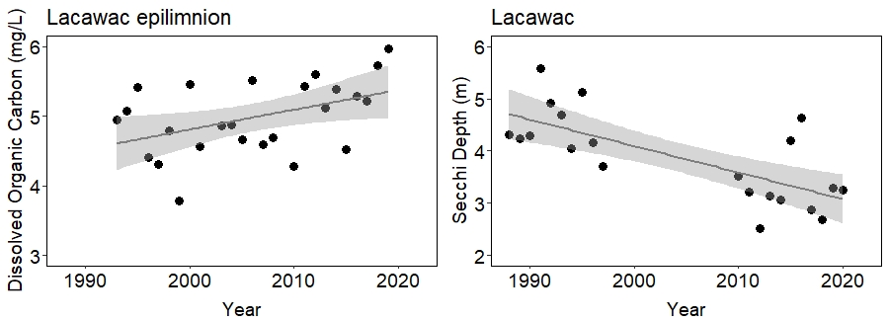

Sample Plot 10: Annual average dissolved organic carbon (DOC) concentrations were measured in the epilimnion of Lake Lacawac. Average annual Secchi depth was measured in Lacawac. Statistically significant trends over time are denoted by the solid trend lines.

Decreasing water transparency has had impacts on the biota in the lake. Using the example of zooplankton, some zooplankton are tactile predators (find their prey by touch), while others are visual predators (find their prey by sight). One would thus expect that a decrease in water transparency could convey a competitive advantage to tactile predators, as they don’t rely on sight to find their prey. Accordingly, as we’ve seen a decrease in water transparency over the past 3 decades the abundance of Cyclopoid copepods (left Sample Plot 11) has increased. Top-down predation would predict a corresponding decrease in their prey, such as the soft-bodied, and “bite-sized” rotifer *Gastropus* (right Sample Plot 11). However, have students keep sharply in their minds that correlation is not causality, even if there seems to be a reasonable mechanism for the correlation. In this case the cyclopoid copepods in Lake Giles are largely the cold stenothermal (preferring cold temperatures) species *Cyclops scutifer*. Examine changes in temperature at the various depths in Lacawac and have students think about the potential importance of changes in temperature in explaining the increases in the cyclopoids. Then have them carry out the same analysis in Lake Giles on temperature and cyclopoid abundance. What do they think might be going on? Have the students focus on potential mechanisms, while understanding the limitations of correlational studies.

Consider that multiple mechanisms may be able to explain why zooplankton groups are differentially affected by changing environments. Central to these differences is the existence of a vertical habitat gradient in lakes. For example, young-of-year fish are most abundant in the well-lit surface waters, so visual predation on zooplankton will be higher here than in the deeper, darker, colder waters, and may account for the decrease in *Daphnia* over time (Sample Plot 8). Studies have indicated that the abundance of larval *Chaoborus* (phantom midge) have increased with increasing DOC in other lakes as well. As these are important predators of *Daphnia*, their increase may also contribute to some of the decrease in *Daphnia* over the time that DOC has been increasing (Williamson et al. 2020). This is another example of how one has to be very careful about inferring causality from correlation over time: multiple things are all going on at the same time, and not all have been measured and recorded.

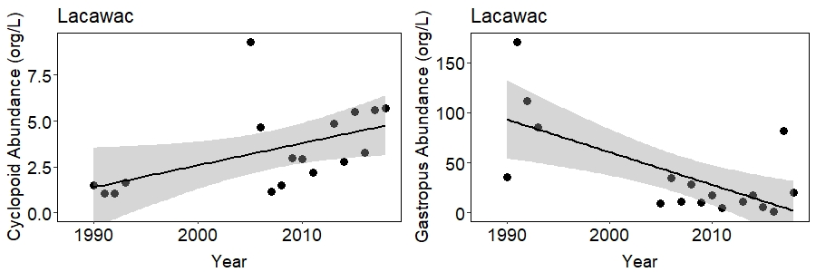

Sample Plot 11: Average summer annual Cyclopoid copepod and *Gastropus* (rotifer species) abundances were measured in Lake Lacawac. Statistically significant trends over time are denoted with a solid trend line.

Instructors: Use the following extension exercise to expand on the questions above. This open-ended exercise is intended for advanced students, who already have some experience working with and analyzing data sets. In this exercise, students are asked to develop their own scientific question(s) using the data set utilized in this app. Students will download the data used in this app and explore it on their own. This exercise requires proficiency working with data, spreadsheet programs, graphing, and statistics. Through this exercise, students will have an opportunity to work with a real-world data set on their own, creating and exploring their own scientific questions. This extension could be used, for example, as a semester project as part of class, or an independent research project.

**Extension:**

This section is intended to build on the skills and concepts learned in the above exercise, and is designed for advanced students (graduate/upper-level undergraduate). The assignment in this section is intentionally open-ended, both in topic and time required to complete the exercise. It is designed to allow students to explore their own questions using the long-term data set introduced in the above exercise.

In the above questions, you were able to explore a single variable’s response over time using plots generated by the app. Now choose your own question on this data set and the patterns seen over time in these lakes. Or expand on one of the questions above. Here you might explore correlations between two variables to further investigate how one factor might be affecting another. For example, in the above questions, we found that as DOC has been increasing in these lakes over the past 3 decades, other components of the lake ecosystem have been changing as well. Exploring correlations between DOC and ecosystem responses could help to strengthen or refute DOC’s effects on the lake ecosystem. Download the needed data and create plots and/or run appropriate statistics to address your question. Data used to generate each selected summary in the app can be downloaded using the “Download data” button, which can be found at the bottom of the “High-Frequency” page, or under the “Table” tab of the “Abiotic” and “Zooplankton” pages. The entire raw data set used in this app can also be downloaded from EDI’s data repository at <https://portal.edirepository.org/nis/mapbrowse?scope=edi&identifier=186>.

Procedure and General Instructions (Student):

**Student Exercise:**

*In the following exercise users will explore data using the web-based app, “Long-Term Changes in the Pocono Lakes”* [*(hyperlink to app)*](https://dataviz.miamioh.edu/PennsylvaniaLakes/) *to answer questions about how lakes are affected by changes in water transparency. Detailed instructions on using the app are available in the “Instructions_PoconoLakesApp” document included with this exercise.*

*Before beginning this exercise, explore the pages of the app to become familiar with the data available. Also, review the “**Approach and Context**”, “**Ecological Background**”, and “**The Lakes**” sections above, as they provide limnological and lake-specific information that will be important as you work through this section.*

For this exercise, you will have access to 30 years of data from three lakes, Lacawac, Giles, and Waynewood (northeastern USA), which represent a range of productivity and water transparency. Giles’s water is of low productivity and relatively transparent, while Lacawac and Waynewood are moderate and more highly productive, respectively, and have much lower water transparency. Water transparency is controlled by particulates such as algae and suspended sediments, and ***dissolved organic matter*** in the water. Here we are going to focus on ways in which dissolved organic matter affects lakes, as particulates tend to be unimportant in controlling transparency in these and many other lakes fed more by seepage than by inlet streams or rivers. Water enters a lake either/ and from above ground sources such as inflowing streams and rivers, or below ground sources such as seepage of water from the ground. Lakes fed mainly by above ground sources are likely to have more inputs of particulates such as suspended sediments, which can influence their water clarity. Lakes such as the ones on which we will be focusing in this exercise are fed mainly by below ground sources through seepage, often through organic-rich soils, and their water clarity is likely to be more affected by dissolved organic matter.

DOM is changing in lakes on a global scale, contributing to lake “***browning***”. Consider how these changes might impact lake ecosystems. Using the data set available through [this app](https://dataviz.miamioh.edu/PennsylvaniaLakes/), explore how changes in transparency have altered the lake ecosystems of Lacawac, Giles, and Waynewood. The following questions are divided into 3 main topics (A-C), with several questions under each topic, all of which can be answered using the lake data set in this app. For each question, describe (in a few sentences) what you see as you plot the data using the app. Key words are ***bolded and italicized*** and linked to their definitions in the glossary.

*Correlation vs. Causation*: Limnologists, ecologists, and other scientists use many approaches to investigate how natural systems work. Experimental approaches manipulate a single variable or set of variables and have a “control” treatment where all other variables are kept constant. This approach enables a scientist to clearly identify causation, and mechanism – what is actually causing an observed change in the response variable. An alternative method that is used in this exercise is to use long-term data to identify how changes in driver variables (e.g. water clarity) correlate with trends in response variables (e.g. temperature and oxygen) over longer periods of time. One important caveat here is that correlation is not causation. For example, at the same time that water clarity is changing due to increases in DOM in these lakes, there could be some alternative explanation for the observed changes in the response variables. During this exercise, you are asked to carefully consider what other changes might occur in lakes that could contribute to the changes in response variables that you are investigating. Think about mechanisms that might drive these changes, and the likelihood of these other variables being important. For example, during browning, there is often a strong increase in pH, and there may be changes in other inputs such as salts from roads that may alter both abiotic and biotic variables in lakes. Cautious and conservative interpretation of long-term data and understanding this critical difference between correlation and causation is a core learning objective in this exercise.

1. Consider how the light environment has changed in these lakes.
   1. How has transparency changed over time in these lakes? The depth to which 1% of subsurface light penetrates is often referred to as the ***1% attenuation depth***, and is a good indicator of water transparency for each of the various wavelengths of light. Conveniently, the 1% attenuation depth for ***PAR*** is the ***compensation******depth***. This is ecologically important because it is the depth below which respiration exceeds photosynthesis, and there is net oxygen consumption and the potential for ***hypoxia*** or ***anoxia*** (low, or no oxygen, respectively). Compare if and how the compensation depth (1% PAR depth) has changed over time in these lakes.
   2. As mentioned above, water transparency is influenced both by particulate and dissolved matter in the lake water. Use the data app to explore what you think may have contributed to these changes in transparency. Consider which variables in the data set might influence water transparency. Through the following two questions, explore how particulate (algae) and dissolved organic matter (measured as dissolved organic carbon, ***DOC***) have changed in each of these lakes.
      1. In this data set, chlorophyll measurements provide an estimate of algal biomass in the lake. How have chlorophyll levels changed over time in these lakes? Is chlorophyll a likely contributor to the observed changes in transparency?
      2. Dissolved organic matter results from incomplete decomposition of primarily terrestrially-derived organic material. It influences water color through lake browning. How have DOC concentrations changed over time in these lakes, and are they a likely contributor to observed changes in water transparency?
2. Light influences many ecological processes in lakes. What do these long-term data tell us about how the changing light environment has affected these lake ecosystems? In the following questions you will explore the implications of changing water transparency for water temperature and dissolved oxygen levels.
3. Has water temperature changed over time in these lakes? Consider the upper (epilimnion) and lower (hypolimnion) layers of the lake. How do you explain any observed changes?
4. In this geographic region, over the time period from 1988 to 2014, ***there were no significant long-term trends in air temperature*** (Pilla et al. 2018). This suggests that changing air temperature during this period was not the primary driver of changes in water temperature. In lake(s) in which you see a significant change in water temperature, how might DOC be influencing these temperature changes over time? More specifically, would you expect surface and deep water temperatures to change in the same way, or opposite ways? Why is this?
5. Oxygen is produced by primary producers (algae) during photosynthesis, and photosynthesis requires light. How would you predict that increasing DOC might influence oxygen levels? How have oxygen levels at shallow and deep depths changed over time, and are these changes related to changes in the light environment in these lakes?
   1. Using data in the “Abiotic” page of the app, explore if and/or how oxygen levels in the upper (epilimnion), middle (metalimnion), and lower (hypoliminion) layers of the lake have been affected. For this question, consider Lake Giles.
   2. Anoxia in the lower waters can cause phosphorus to be released from the sediments, reintroducing nutrients to the water column and fueling algal growth. Anoxic conditions become more likely towards the end of the summer, as oxygen may be used up and not replenished during the period of summer ***stratification***.
      * + Have these lakes had significant drops in oxygen levels in the deeper waters of the lake? Use dissolved oxygen data on the “High-frequency” page to look at these patterns.
        + How might increasing DOM increase the likelihood of anoxic conditions?
6. In the previous questions we explored changes in the abiotic components of the lake due to changes in the light environment. Now consider impacts on the biotic communities.
   1. Light is essential for photosynthesis. In the open waters of these lakes (the pelagic zone) the predominant primary producers are phytoplankton (algae). Phytoplankton are found throughout the water column where light levels are high enough to support photosynthesis, typically where PAR is >= 1% of surface levels (1% PAR depth). Algal biomass is estimated through measurements of chlorophyll concentrations in lake water. In the following questions you will consider how the changing light environment may have affected the primary producers.
      1. Giles is a relatively clear lake. In the early 1990s light (photosynthetically active radiation, PAR) penetrated to the bottom of the 22 m water column in levels high enough to support primary production (1% PAR depth). Revisit how Giles’s 1% PAR depths have changed over time (question 1). Has this affected primary production in the lower depths of Giles (hypolimnion)? How?
   2. As light is made up of visible and UV wavelengths, it has effects on the biota in the lake, both through the damaging effects of UV on some organisms, and reduced visibility for others with decreases in visible light. While changes in UV and visible light directly affect some species, others are indirectly affected as through predation and food supply. In the following questions you will consider how zooplankton communities have been affected as DOC levels have increased. As you answer these questions, consider the following pelagic food chains:



In both of these aquatic food chains, zooplankton are the critical intermediate link that can control both water quality (by grazing on bacteria and algae) and fish production (by providing food for smaller fish that are eaten by larger fish). The first shows the top-down effects of fish predation on zooplankton, and hence phytoplankton, while the second shows the bottom-up effects of food supply (phytoplankton) on zooplankton and fish. As you answer the following questions, consider whether phytoplankton (bottom-up) or fish (top-down) are more likely to be responsible for the changes you observe in the zooplankton communities.

These zooplankton communities are made up of the major zooplankton groups including rotifers, copepods, and cladocerans such as *Daphnia*. *Daphnia* and many copepods are generally larger in body size, and rotifers are smaller. *Daphnia* feed primarily by grazing on algae and bacteria, while copepods are more omnivorous, feeding on other small zooplankton including rotifers as well as larger algae. Rotifers most often graze on bacteria and algae, but some of the larger species are predatory and can feed on other rotifers. In the following questions you’ll be asked to consider how various groups of these zooplankton have changed over time and between lakes.

* + 1. Let’s look at zooplankton communities over the past 3 decades. Using data from Lake Giles, how have *Daphnia* populations changed?
    2. Refer to the above food chain diagrams. As *Daphnia* are grazers (consume phytoplankton) they can be affected by bottom-up effects of their phytoplankton food supply as well as top-down predation by fish. Over the past 3 decades there has been a marked increase in larval fish abundance, which is believed to have resulted from the combined effects of reduced UV light penetration with browning and increased pH with recovery from acid deposition (Table 1). Revisit the chlorophyll data in the epilimnion of Lake Giles to explore how phytoplankton biomass has changed over the past 3 decades. Which biotic component (fish or phytoplankton) is more likely to be responsible for the observed changes in *Daphnia*? What role might changes in pH have played? Explain.

|  |  |  |
| --- | --- | --- |
| **Lake** | **CPUE 1990** | **CPUE 2014** |
| Giles | 0.0 | 5.5 |
| Lacawac | 1.6 | 5.0 |

Table 1: Catch per unit effort (CPUE) of juvenile planktivorous (young-of-year, YOY) fish was measured in 1990 and in 2014 in Lakes Giles and Lacawac. *From Williamson et al. 2015;* [*https://doi.org/10.1038/srep18666*](https://doi.org/10.1038/srep18666)*.*

* + 1. As DOC increases, visibility decreases, thus favoring predators that find their prey by touch (tactile predators) over those that rely on sight (visual predators). Some larger zooplankton (such as copepods) prey upon smaller zooplankton (rotifers). In these lakes, Cyclopoid copepods are common tactile predators that feed upon smaller rotifers such as *Gastropus*. Using Lacawac’s data, consider how water transparency has changed over the past 30 years. How has this affected the abundances of Cyclopoid copepods and their prey?

**Extension:**

In the above questions you were able to explore a single variable’s response over time using plots generated by the app. Now choose your own question on this data set and the patterns seen over time in these lakes. Or expand on one of the questions above. Here you might explore correlations between two variables to further investigate how one factor might be affecting another. For example, in the above questions we found that as DOC has been increasing in these lakes over the past 3 decades other components of the lake ecosystem have been changing as well. Exploring correlations between DOC and ecosystem responses could help to strengthen or refute DOC’s effects on the lake ecosystem. Download the needed data and create plots and/or run appropriate statistics to address your question. Data used to generate each selected summary in the app can be downloaded using the “Download data” button, which can be found at the bottom of the “High-Frequency” page, or under the “Table” tab of the “Abiotic” and “Zooplankton” pages. The entire raw data set used in this app can also be downloaded from EDI’s data repository at <https://portal.edirepository.org/nis/mapbrowse?scope=edi&identifier=186>.

Glossary:

**Anoxia** occurs when oxygen is completely consumed in a portion of a water body. These anoxic waters can be found in the deep waters of a lake when oxygen is completely consumed by respiration, and is unable to be replenished by photosynthesis, as light levels are too low for photosynthesis, and stratification prevents the shallower, oxygenated waters from being mixed.

**1% attenuation depth** is the depth to which 1% of subsurface light penetrates through the water column. The 1% depth can be measured for the various wavelengths of light, and is a good indicator of water transparency. The greater the 1% depth, the further light is able to penetrate down through the water column, and thus the more transparent the water.

**Browning**, or lake browning, refers to the coloration of water by dissolved organic matter. Organic material leaches out into lake water, resulting in brownish coloration of the water. This browning has impacts for water transparency and water temperature, as light is able to penetrate less far through dark water, and this dark water absorbs more heat from sunlight. Importantly, browning is often accompanied by recovery from acidification and thus a corresponding increase in pH.

**Compensation depth** is the depth at which photosynthesis and respiration are equal. This depth is equal to the 1% attenuation depth for PAR. Above this depth photosynthesis exceeds respiration, and below this depth light levels are insufficient, and respiration exceeds photosynthesis.

**Dissolved organic carbon (DOC)** is a measurement of the amount of carbon in dissolved organic matter (DOM) levels in water. DOC is organic carbon leached into water from organic substances either in the lake, or within the watershed, or from the atmosphere (airshed).

**Dissolved organic matter (DOM)** is organic material that leaches into the water, resulting in coloration of the water, a phenomenon referred to as “lake browning”. DOM results from incomplete decomposition of organic material (leaf litter, plant exudates, etc.), and is largely terrestrially-derived. It can be measured as dissolved organic carbon (DOC).

**Hypoxia** occurs when oxygen is reduced below saturation concentrations in a portion of a water body, resulting in very low oxygen levels. Like anoxia, these hypoxic waters can be found in the deep waters of a lake when oxygen is consumed by respiration, and is unable to be replenished by photosynthesis, as light levels are too low for photosynthesis, and stratification prevents the shallower, oxygenated waters from being mixed more deeply.

**PAR**, or photosynthetically active radiation, is light that falls within the wavelengths of 400-700 nm, and is used for photosynthesis. These are essentially the same wavelengths as visible light.

**Lake stratification** occurs when surface waters are warmer than deeper waters, such as in the summer in temperate lakes. The water column often becomes stratified into 3 distinct layers with different patterns of temperature and oxygen. These layers remain somewhat separated from each other until turnover, when they are again mixed. The top layer, the epilimnion, consists of well mixed highly oxygenated water of uniform, relatively warm temperature. The middle layer, the metalimnion, contains a thermocline, or temperature gradient, where temperature decreases with increasing depth. The bottom layer, the hypolimnion, consists of relatively cool water of uniform temperature and low oxygen (hypoxia) or no oxygen (anoxia). The following image illustrates an example of how the waters of a temperate lake stratify during the summer.

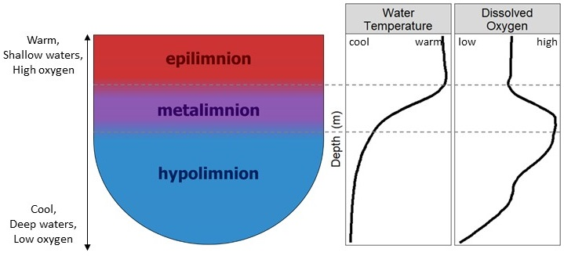

**Lake turnover** occurs in the spring and fall in temperate lakes, when the entire water column mixes. This results in a redistribution of oxygen and resources throughout the water column.

**UV radiation**, or ultraviolet radiation, includes the wavelengths of light across the ultraviolet spectrum (100-400 nm). These wavelengths impact lake ecosystems, including through the damaging effects on organisms of UV light, and through solar disinfection of parasites and pathogens, due to the damaging effects of UV on these organisms. As with PAR, the penetration of UV light through the water column is impacted by water transparency, and lake browning. Levels of UV radiation in the lake have implications for the vertical distribution and abundance of various organisms throughout the water column.

References and Relevant Publications:

*The following includes publications referenced in the above document, as well as suggested readings to expand on the topics covered in this exercise. Readings that involve the study lakes in this exercise are denoted with an asterisk.*

Bunnell, DB, Ludsin SA, Knight RL, *et al*. Consequences of changing water clarity on the fish and fisheries of the Laurentian Great Lakes. Canadian Journal of Fisheries and Aquatic Sciences. *In Press.*

DeWit HA, Valinia S, Weyhenmeyer GA, *et al.* 2016. Current browning of surface waters will be further promoted by wetter climate. Environmental Science and Technology Letters **3**: 430-435. <https://doi.org/10.1021/acs.estlett.6b00396>

Gocic M and Trajkovic S 2013. Analysis of changes in meteorological variables using Mann-Kendall and Sen’s slop estimator statistical tests in Serbia. Global and Planetary Change **100**: 172-182. <https://doi.org/10.1016/j.gloplacha.2012.10.014>

*Knoll LB, Williamson CE, Pilla RM*, et al.* 2018. Browning-related oxygen depletion in an oligotrophic lake. Inland Waters **8**: 255-263. <https://doi.org/10.1080/20442041.2018.1452355>

Leech DM, Pollard AI, Labou SG, Hampton SE. 2018. Fewer blue lakes and more murky lakes across the continental U.S.: Implications for planktonic food webs. Limnology and Oceanography **63**: 2661-2680. <https://doi.org/10.1002/lno.10967>

Monteith DT, Stoddard JL, Evans CD, *et al*. 2007. Dissolved organic carbon trends resulting from changes in atmospheric chemistry. Nature **450**: 537-541. <https://doi.org/10.1038/nature06316>

Neale PJ, Williamson CE, Morris DP. 2020. Optical Properties of Water. Encyclopedia of Inland Waters, 2nd edition. *In Press*.

Oliver SK, Collins SM, Soranno PA, et al. 2017. Unexpected stasis in a changing world: Lake nutrient and chlorophyll trends since 1990. Global Change Biology **23**: 5455-5467. <https://doi.org/10.1111/gcb.13810>

*Pilla RM, Williamson CE, Zhang J*, et al.* 2018. Browning-related decreases in water transparency lead to long-term increases in surface water temperature and thermal stratification in two small lakes. Journal of Geophysical Research: Biogeosciences **123**: 1651-1665. <https://doi.org/10.1029/2017JG004321>

[Solomon, C. T., S. E. Jones, B. C. Weidel, I. Buffam, M. L. Fork, J. Karlsson, S. Larsen, J. T. Lennon, J. S. Read, S. Sadro and J. E. Saros (2015). Ecosystem consequences of changing inputs of terrestrial dissolved organic matter to lakes: Current knowledge and future challenges. Ecosystems **18**: 376-389.](https://link.springer.com/article/10.1007/s10021-015-9848-y) <https://doi.org/10.1007/s10021-015-9848-y>

Strock KE, Theodore N, Gawley WG, *et al.* 2017. Increasing dissolved organic carbon concentrations in northern boreal lakes: Implications for lake water transparency and thermal structure. Journal of Geophysical Research: Biogeosciences **122**: 1022-1035.<https://doi.org/10.1002/2017JG003767>

*Williamson, CE, DP Morris, ML Pace and OG Olson 1999. Dissolved organic carbon and nutrients as regulators of lake ecosystems: Resurrection of a more integrated paradigm. Limnology and Oceanography **44**: 795-803.

*Williamson CE, Overholt EP, Pilla RM*, et al.* 2015. Ecological consequences of long-term browning in lakes. Scientific Reports **5**: 18666. <https://doi.org/10.1038/srep18666>

*Williamson CE 2020. Lake management in a browning world: Beyond the holy grail of nutrients. LakeLine: 6-10. <https://www.nalms.org/product/lakeline-40-1-lake-browning/>

Williamson, CE, and Neale PJ. 2020. Ultraviolet Radiation. Encyclopedia of Inland Waters, 2nd edition. *In Press*

*Williamson CE, Overholt EP, Pilla RM, *et al*. 2020. Habitat-mediated responses of zooplankton to decreasing light in two temperate lakes undergoing long-term browning. Frontiers in Environmental Science **8**. [https://doi.org/10.3389/fenvs.2020.00073](https://www.frontiersin.org/articles/10.3389/fenvs.2020.00073/full)

Class Demonstration:

Dissolved Organic Matter Demonstration

The following (optional, and very simple) demonstration can be used by the instructor or groups of students to illustrate how DOC affects water transparency. In this demonstration tea bags are steeped for various amounts of time to create solutions of relatively high, medium, and low concentrations of DOC, allowing you to show how water transparency can be impacted by DOC. Black tea was used in this example, but other types of tea may be used for similar results, but the water color will vary. Allow approximately a half hour to complete and discuss this demonstration.

In this exercise you will use tea to demonstrate how dissolved organic matter affects water transparency. Tea is a common example of DOM in our everyday life. Steeping tea leaves extracts DOM from the leaves, which gives tea its colored appearance. In this exercise you’ll create jars of various tea concentrations to show how this gradient of DOM concentrations affects transparency.

*Supplies:*

* *3 beakers or other heat-stable glass jars that will not crack with boiling water. In this example pint-sized canning jars were used (need to pre-warm well to avoid cracking).*
* *2 black tea bags*
* *Boiling water (750 mL)*
* *DOM Demonstration template (print the following page in this document)*

Instructions:

Label your jars with the numbers 1, 2, and 3. Pour 250 mL of boiling water into each jar. Place a tea bag each in jars 2 and 3. Allow the tea bags to steep for 10 seconds in jar 2 and 5 minutes in the jar 3. Remove the tea bags after steeping. You should now have 3 jars of various shades of clear to brown water. With no tea bags, jar 1’s water is completely clear and transparent, while jars 2 and 3 are various shades of brown and transparency. Observe how the “darkness” of the water affects transparency. Place the jars on the black and white circles on the “DOM Demonstration” template. Which jar’s water is it the easiest to see through? Hardest?

Black and white disks similar in appearance to these circles are used by aquatic scientists and lake managers to measure water clarity. These Secchi disks are lowered through the water column by a rope, and the depth at which the disk disappears from view is recorded as the “Secchi depth”. Clear lakes will have a deep Secchi depth, where as less transparent lakes will have lower Secchi depths, as dissolved and particulate matter in the water column will affect how deep in the water column the Secchi disk can be seen.

DOM in lakes and streams works in much the same way. Dissolved organic matter leaches out of organic matter, including leaves from plants, into the water. The “darkness” of the water is affected by the amount of DOM that has leached into the water, and this darkness determines the water transparency (how far you can see or how far light can penetrate through the water). In this demonstration, jar 3 had the highest concentration of DOM and the darkest water as organic matter from the tea bag was allowed to leach for the longest time into it, jar 2 had low DOM and light water, and jar 1 had no added DOM and clear water. As in this example where it was easiest to see the black and white circle under the jar with the lowest DOM (jar 1), light can penetrate to deeper depths through water with low DOM than with high DOM. Just as the darkness of the water is affected by the amount of DOM that has leached into it, the color of the water is affected by the specific material from which the DOM has come. Different types of plants leach different colors of organic matter into the water. You could repeat this exercise using a different type of tea, and while you would get somewhat different coloration of the water (i.e., try this exercise with green tea or rooibos), you would still see the same variation in “darkness” with the time over which tea leaves were steeped.

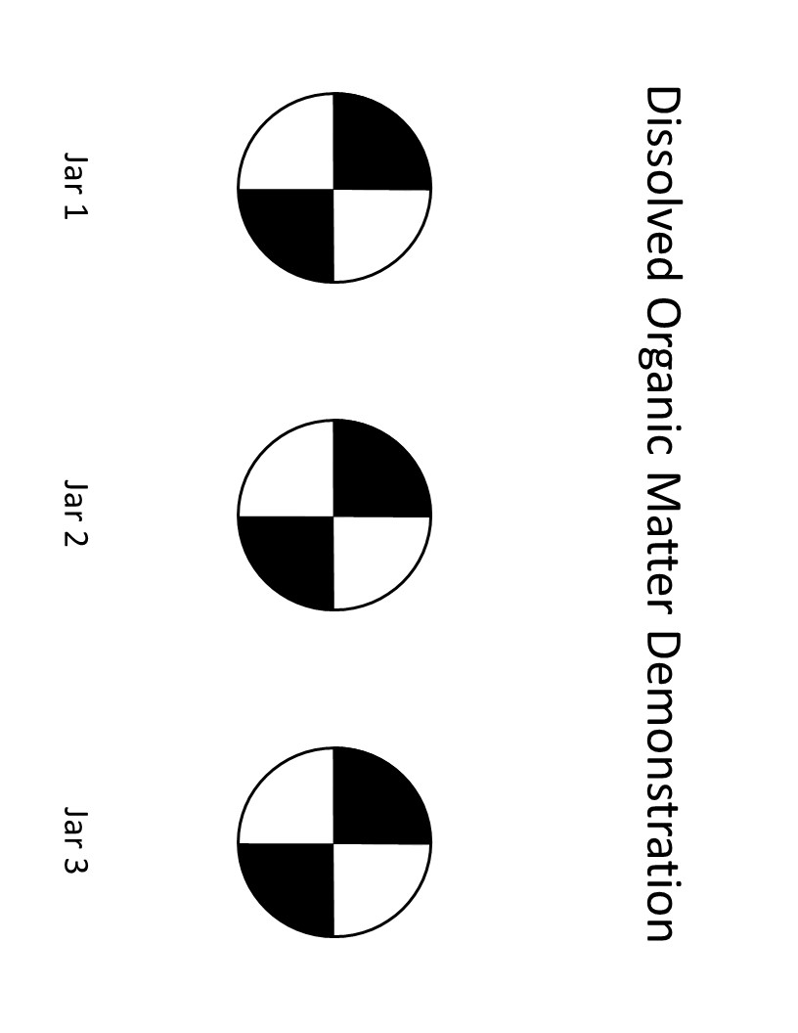

*Instructors:* The images below show what water will look like for the above exercise. Note the differences in color and transparency between the jars. Ask students to make predictions about how these differences in transparency might affect the lake environment, and keep these observations in mind as they explore the lake data in this exercise.

