***Geographic Gradients in Community Patterns of Forest Trees***

**Tom A. Langen, Clarkson University**

**I. BACKGROUND**

An ***ecological*** ***community*** is a group of interacting or potentially interacting species inhabiting the same geographic location. To compare communities, we typically focus on some natural groups of organisms that are components of the communities, more correctly referred to as ***community assemblages***. Community assemblages used to compare communities include tree species, bird species, fish species, or other such functionally or taxonomically natural groups.

Two fundamental properties used to describe an ecological community are ***species richness*** (the number of species) and the patterns of ***relative abundance.*** The relative abundance of a species is the proportion of all individuals in a community that are of that species. A community in which all relative abundances are similar would be characterized as ***even***. A community that is dominated by one species (high relative abundance), with all others being rare (low relative abundances) would be characterized as highly uneven. There are a number of ‘indices of diversity’ that are intended to quantify the evenness of the relative abundances of species that comprise a community assemblage (e.g. Shannon-Wiener Index, Simpson’s Index).

In principal, species richness and patterns of relative abundance would seem to be two community properties that would vary independently. It is for this reason that ecologists often describe a community by both the species richness and an index of diversity. However, empirically it is often observed that species poor communities are highly uneven in abundance, whereas species rich communities are more even. In other words, species poor communities are highly dominated by one or a few species, whereas species rich communities have many equally common species.

Species richness patterns show a strong latitudinal pattern for most assemblages of terrestrial organisms: species richness increases as you move from high latitudes to low (e.g. poles to tropics). There is often a gradient from coasts to inland on continents that tracks precipitation and climate variability: generally a wetter and more stable climate on the coast than the continent’s interior results in higher species richness on the coast than interior. Sites located on a continental land mass tend to have more species than islands.

Are there continental scale gradients in the evenness of relative abundances that parallel the gradients in species richness?

**Rank Abundance Curves**

There are many ways to quantify relative abundance patterns, for example by the so-called diversity indices (Magurran 2004). However, one of the simplest and most interpretable ways to compare patterns of relative abundances is visually via a ***rank abundance curve***, also known as a Whittaker plot after its inventor, the eminent community ecologist Robert Whittaker (Whittaker 1965).

A rank abundance curve provides information on both species richness and the evenness of relative abundances within a species assemblage. In such a graph, the x-axis is the rank order of species from the most abundant to least abundant species (the most common species’ rank = 1, second most common = 2 etc., and the rarest species is rank = N, where N is the total number of species in the community). The y-axis is the relative abundance, on a log 10 scale. A very steep curve indicates highly uneven relative abundances among the species within the assemblage, whereas a gradual slope indicates a much more even distribution of relative abundances.

In the figure below, the relative abundances of forest trees sampled in 2004-2005 at two locations (Flathead County, Montana; Clarke County, Alabama) are compared. The Alabama forest has more species (59 vs. 15 species). The Alabama forest is also more even among relative abundances overall, as indicated by the less-steep slope of the curve. However, the Montana site is actually more even among relative abundances if only the five most abundant species are included. About 45% of all trees at the Alabama forest are of the single most common species, whereas 30% of all trees at the Montana forest are of its most common species.



**References**

Magurran, Anne E. (2004). Measuring biological diversity. Oxford: Blackwell.

Whittaker, R. H. 1965. Dominance and diversity in land plant communities: Numerical relations

of species express the importance of competition in community function and evolution. Science 147: 250–260.

**II. THE EXERCISE**

The objective of this exercise is to compare relative abundances of trees among a selection of North American forest locations, to evaluate whether there are continental scale patterns of relative abundances of forest trees that parallel continental scale patterns of species richness. The data are extracted from the US Forest Service Forest Inventory and Analysis (FIA) Program (<http://www.fia.fs.fed.us/>). During periodic surveys, the US Forest Service collects forest inventory data throughout the US using a structured sampling plan (details at <http://www.fia.fs.fed.us/library/fact-sheets/>). The FIA is a monumental data set that provides a continuous record of the structure and composition of forests in the US, Puerto Rico and the Virgin Islands.

We will use a platform called Science Pipes (<http://info.sciencepipes.org/about/>). The Science Pipe we will use extracts selected data from the FIA database, ranks species and calculates their relative abundances, provides the data in tabular form, and plots the data in a rank abundance curve. The FIA data used in the Science Pipe are preselected for one county per state, and include all data from 1999 to 2010; states vary in how many years of data were collected within this interval.

**Instructions**

1. Go to Science Pipes (<http://sciencepipes.org/beta/home>), and register by clicking **Get Started**
2. Make sure you are logged in
3. Search for the pipe **Forest Tree Population Structure: Rank Abundance Curves**
4. If you see multiple pipes by that name, select the pipe that was created by Tom Langen. After you open that pipe, select from the menu bar the option **Run**
5. You will see a list of nine US Forest Service regions (Alaska, Eastern, Intermountain, Northern, etc.). Multiple sites are nested within each scroll-down menu. The list is repeated four times (County Filter 1, County Filter 2, etc.).
6. Select using a button or scroll-down menu states in the following order

County Filter 1 = **Alaska Prince of Wales-Outer Ketchikan Census Area** (only one in

Alaska Region)

County Filter 2 = **Washington Okanogon** (in the Pacific Northwest Region)

County Filter 3 = **Oregon Klamath** (in the Pacific Northwest Region)

County Filter 4 = **California Siskiyou** (only one in Pacific Southwest Region)

The label for each is the state followed by the county name.

1. Select **Run Pipe**, at the bottom of the page. Wait – it may take a few minutes to run.
2. Once it has finished, scroll down the page. You will see tables for each site. Click on the table menu option **TABLE**, then sort by **Rank Order**. You will be able to see the names of each species, its relative abundance (as a proportion) and rank abundance at the site. It should look something like this:

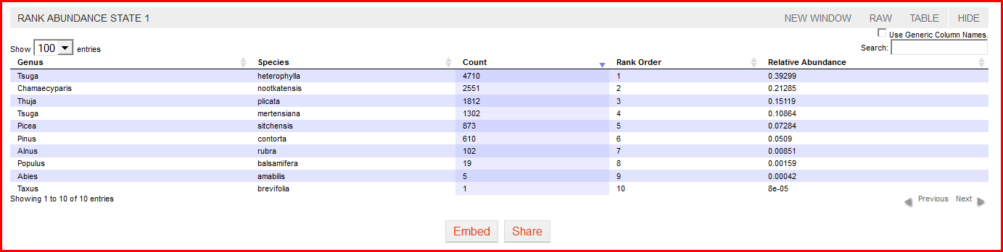

1. 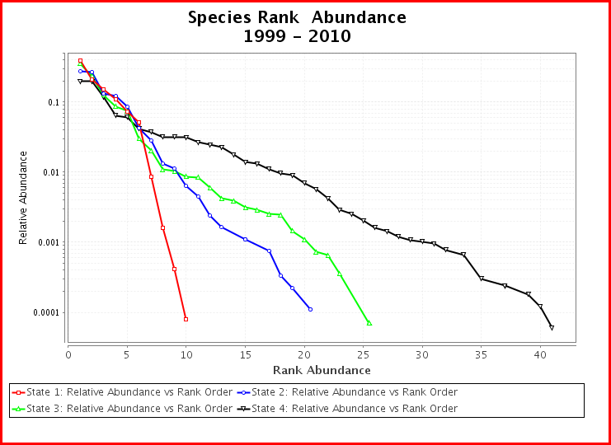As you scroll down, you should see a rank abundance curve with the four sites. It will look like this:
2. Fill in the table on the worksheet. The species richness (number of species) can be read from the x-axis of the rank abundance curve, or by the number of species listed on the output data table for the state. To find out the name and abundance of the most abundant species (MAS), sort the output data table. The table provides the relative proportion – you need to multiply by 100 to get the percentage. The first row of the table has been completed to provide an example.
3. Take a screen shot of the rank abundance curve (using the Snipping Tool or similar utility) and paste it into the answer sheet.
4. The four sites are in a latitudinal gradient along the west coast of North America: State 1 (northernmost) > State 2 > State 3 > State 4 (southernmost).
5. *Do you detect the expected latitudinal gradient in species richness?*
6. *Do you detect the expected latitudinal gradient in dominance by the most abundant species?*

(c) *Is there a latitudinal gradient in species evenness?*

Answer these three questions, in one or two sentences, on your answer sheet, below the rank abundance curve.

1. Click the top menu bar option **RUN.** At the bottom of the page, click **Reset Form.**
2. Now it is your turn to select a latitudinal (North-South) transect of states. Select one state for each of the four County Filters that lie along approximately the same longitude. Make the option selected for County Filter 1 be a state along the northern border (e.g. Montana, Minnesota, Michigan, Maine). County Filter 2 should be a state that lies to the south of the first, County Filter 3 should be a state that lies south of County Filter 2, and County Filter 4 should be along the southern border (e.g. Arizona, Texas, Mississippi, Florida) or the two tropical island sites (Puerto Rico, Virgin Islands). You may want to refer to a US map to make sure the states are along the same longitude (e.g. <http://www.nationsonline.org/oneworld/usa_map.htm>)  
     
   Remember, each Region option is a scroll-down menu. Puerto Rico and the Virgin Islands are in the southern region. Unfortunately, there are no data for Hawaii.
3. Once you have selected your four states, click **Run Pipe.** Fill out the data table, andtake a screen shot of the resulting rank abundance curve and paste it in your document.
4. Repeat two more times, so you have a total of four rank abundance curves, generated from four latitudinal transects of states, pasted in your answer sheet. Make sure at least one transect is comprised of states along the US east (Atlantic) coast. Note that because the east coast runs northeast – southwest, the east coast transect will not be on the same longitudinal line.
5. Compare all four latitudinal transects, and answer the following questions in one or two sentences on the answer sheet:
6. *Do you detect the expected latitudinal gradient in species richness?*
7. *Do you detect the expected latitudinal gradient in dominance by the most abundant species?*
8. *Is there a latitudinal gradient in species evenness?*
9. *Are the coastal sites more species rich and even in relative abundance than continental interior sites of the same latitude?*

(d) *If there are species rank abundance patterns that don’t appear to fit the expected gradients, can you provide a hypothesis that may account for the patterns you do see?*